pygame 2.6.1 (SDL 2.28.4, Python 3.9.6)

Last login: Tue Apr 29 18:21:43 on console
sam@M1 ~ % python3

Type help() for interactive help, or help(object) for help about object.
>>> help()

Welcome to Python 3.9's help utility!

If this is your first time using Python, you should definitely check out
the tutorial on the Internet at https://docs.python.org/3.9/tutorial/.

Enter the name of any module, keyword, or topic to get help on writing
Python programs and using Python modules. To quit this help utility and
return to the interpreter, just type "quit".

To get a list of available modules, keywords, symbols, or topics, type
"modules", "keywords", "symbols", or "topics". Each module also comes
with a one-line summary of what it does; to list the modules whose name
or summary contain a given string such as "spam", type "modules spam".

help>

topics

Here is a list of available topics. Enter any topic name to get more help.

ASSERTION DELETION LOOPING SHIFTING
ASSIGNMENT DICTIONARIES MAPPINGMETHODS SLICINGS
ATTRIBUTEMETHODS DICTIONARYLITERALS MAPPINGS SPECIALATTRIBUTES
ATTRIBUTES DYNAMICFEATURES METHODS SPECIALIDENTIFIERS
AUGMENTEDASSIGNMENT ELLIPSIS MODULES SPECIALMETHODS
BASICMETHODS EXCEPTIONS NAMESPACES STRINGMETHODS
BINARY EXECUTION NONE STRINGS
BITWISE EXPRESSIONS NUMBERMETHODS SUBSCRIPTS
BOOLEAN FLOAT NUMBERS TRACEBACKS
CALLABLEMETHODS FORMATTING OBJECTS TRUTHVALUE
CALLS FRAMEOBJECTS OPERATORS TUPLELITERALS
CLASSES FRAMES PACKAGES TUPLES
CODEOBJECTS FUNCTIONS POWER TYPEOBJECTS
COMPARISON IDENTIFIERS PRECEDENCE TYPES
COMPLEX IMPORTING PRIVATENAMES UNARY
CONDITIONAL INTEGER RETURNING UNICODE
CONTEXTMANAGERS LISTLITERALS SCOPING
CONVERSIONS LISTS SEQUENCEMETHODS
DEBUGGING LITERALS SEQUENCES

help>

modules

Please wait a moment while I gather a list of all available modules...

pygame 2.6.1 (SDL 2.28.4, Python 3.9.6)
Hello from the pygame community. https://www.pygame.org/contribute.html
__future__ _thread glob rlcompleter
_abc _threading_local graphlib runpy
_aix_support _tkinter grp sched
_ast _tracemalloc gzip secrets
_asyncio _uuid hashlib select
_bisect _warnings heapq selectors
_blake2 _weakref hmac setuptools
_bootlocale _weakrefset html shelve
_bootsubprocess _xxsubinterpreters http shlex
_bz2 _xxtestfuzz imaplib shutil
_codecs _zoneinfo imghdr signal
_codecs_cn abc imp site
_codecs_hk aifc importlib six
_codecs_iso2022 altgraph inspect smtpd
_codecs_jp antigravity io smtplib
_codecs_kr argparse ipaddress sndhdr
_codecs_tw array itertools socket
_collections ast json socketserver
_collections_abc asynchat keyword sqlite3
_compat_pickle asyncio lib2to3 sre_compile
_compression asyncore libfuturize sre_constants
_contextvars atexit libpasteurize sre_parse
_crypt audioop linecache ssl
_csv base64 locale stat
_ctypes bdb logging statistics
_ctypes_test binascii lzma string
_curses binhex macholib stringprep
_curses_panel bisect mailbox struct
_datetime builtins mailcap subprocess
_dbm bz2 marshal sunau
_decimal cProfile math symbol
_distutils_hack calendar mimetypes symtable
_elementtree cgi mmap sys
_functools cgitb modulefinder sysconfig
_hashlib chunk multiprocessing syslog
_heapq cmath netrc tabnanny
_imp cmd nis tarfile
_io code nntplib telnetlib
_json codecs ntpath tempfile
_locale codeop nturl2path termios
_lsprof collections numbers textwrap
_lzma colorsys numpy this
_markupbase compileall opcode threading
_md5 concurrent operator time
_multibytecodec configparser optparse timeit
_multiprocessing contextlib os tkinter
_opcode contextvars parser token
_operator copy past tokenize
_osx_support copyreg pathlib trace
_peg_parser crypt pdb traceback
_pickle csv pgzero tracemalloc
_posixshmem ctypes pgzrun tty
_posixsubprocess curses pickle turtle
_py_abc dataclasses pickletools turtledemo
_pydecimal datetime pip types
_pyio dbm pipes typing
_queue decimal pkg_resources unicodedata
_random difflib pkgutil unittest
_scproxy dis platform urllib
_sha1 distutils plistlib uu
_sha256 doctest poplib uuid
_sha3 email posix venv
_sha512 encodings posixpath warnings
_signal ensurepip pprint wave
_sitebuiltins enum profile weakref
_socket errno pstats webbrowser
_sqlite3 faulthandler pty wheel
_sre fcntl pwd wsgiref
_ssl filecmp py_compile xdrlib
_stat fileinput pyclbr xml
_statistics fnmatch pydoc xmlrpc
_string formatter pydoc_data xxlimited
_strptime fractions pyexpat xxsubtype
_struct ftplib pygame zipapp
_symtable functools queue zipfile
_sysconfigdata__darwin_darwin future quopri zipimport
_testbuffer gc random zlib
_testcapi genericpath re zoneinfo
_testimportmultiple getopt readline
_testinternalcapi getpass reprlib
_testmultiphase gettext resource

Enter any module name to get more help. Or, type "modules spam" to search
for modules whose name or summary contain the string "spam".

help>



pygame documentation
Pygame Home || Help Contents || Reference Index

Most useful stuff: Color | display | draw | event | font | image | key | locals | mixer | mouse | Rect | Surface | time | music | pygame
Advanced stuff: cursors | joystick | mask | sprite | transform | BufferProxy | freetype | gfxdraw | midi | PixelArray | pixelcopy | sndarray | surfarray | math
Other: camera | controller | examples | fastevent | scrap | tests | touch | version
pygame.examples
module of example programs
pygame.examples.aliens.main | play the full aliens example
pygame.examples.stars.main | run a simple starfield example
pygame.examples.chimp.main | hit the moving chimp
pygame.examples.moveit.main | display animated objects on the screen
pygame.examples.fonty.main | run a font rendering example
pygame.examples.freetype_misc.main | run a FreeType rendering example
pygame.examples.vgrade.main | display a vertical gradient
pygame.examples.eventlist.main | display pygame events
pygame.examples.arraydemo.main | show various surfarray effects
pygame.examples.sound.main | load and play a sound
pygame.examples.sound_array_demos.main | play various sndarray effects
pygame.examples.liquid.main | display an animated liquid effect
pygame.examples.glcube.main | display an animated 3D cube using OpenGL
pygame.examples.scrap_clipboard.main | access the clipboard
pygame.examples.mask.main | display multiple images bounce off each other using collision detection
pygame.examples.testsprite.main | show lots of sprites moving around
pygame.examples.headless_no_windows_needed.main | write an image file that is smoothscaled copy of an input file
pygame.examples.joystick.main | demonstrate joystick functionality
pygame.examples.blend_fill.main | demonstrate the various surface.fill method blend options
pygame.examples.blit_blends.main | uses alternative additive fill to that of surface.fill
pygame.examples.cursors.main | display two different custom cursors
pygame.examples.pixelarray.main | display various pixelarray generated effects
pygame.examples.scaletest.main | interactively scale an image using smoothscale
pygame.examples.midi.main | run a midi example
pygame.examples.scroll.main | run a Surface.scroll example that shows a magnified image
pygame.examples.camera.main | display video captured live from an attached camera
pygame.examples.playmus.main | play an audio file
These examples should help get you started with pygame. Here is a brief rundown of what you get. The source code for these examples is in the public domain. Feel free to use for your own projects.
There are several ways to run the examples. First they can be run as stand-alone programs. Second they can be imported and their main() methods called (see below). Finally, the easiest way is to use the python -m option:
python -m pygame.examples.<example name> <example arguments>
eg:
python -m pygame.examples.scaletest someimage.png
Resources such as images and sounds for the examples are found in the pygame/examples/data subdirectory.
You can find where the example files are installed by using the following commands inside the python interpreter.
import pygame.examples.scaletest
pygame.examples.scaletest.__file__
'/usr/lib/python2.6/site-packages/pygame/examples/scaletest.py'
On each OS and version of Python the location will be slightly different. For example on Windows it might be in 'C:/Python26/Lib/site-packages/pygame/examples/' On Mac OS X it might be in '/Library/Frameworks/Python.framework/Versions/2.6/lib/python2.6/site-packages/pygame/examples/'
You can also run the examples in the python interpreter by calling each modules main() function.
import pygame.examples.scaletest
pygame.examples.scaletest.main()
We're always on the lookout for more examples and/or example requests. Code like this is probably the best way to start getting involved with python gaming.
examples as a package is new to pygame 1.9.0. But most of the examples came with pygame much earlier.
aliens.main()
play the full aliens example
aliens.main() -> None
This started off as a port of the SDL demonstration, Aliens. Now it has evolved into something sort of resembling fun. This demonstrates a lot of different uses of sprites and optimized blitting. Also transparency, colorkeys, fonts, sound, music, joystick, and more. (PS, my high score is 117! goodluck)

stars.main()
run a simple starfield example
stars.main() -> None
A simple starfield example. You can change the center of perspective by leftclicking the mouse on the screen.

chimp.main()
hit the moving chimp
chimp.main() -> None
This simple example is derived from the line-by-line tutorial that comes with pygame. It is based on a 'popular' web banner. Note there are comments here, but for the full explanation, follow along in the tutorial.

moveit.main()
display animated objects on the screen
moveit.main() -> None
This is the full and final example from the Pygame Tutorial, "How Do I Make It Move". It creates 10 objects and animates them on the screen.
Note it's a bit scant on error checking, but it's easy to read. :] Fortunately, this is python, and we needn't wrestle with a pile of error codes.

fonty.main()
run a font rendering example
fonty.main() -> None
Super quick, super simple application demonstrating the different ways to render fonts with the font module

freetype_misc.main()
run a FreeType rendering example
freetype_misc.main() -> None
A showcase of rendering features the pygame.freetype.FontCreate a new Font instance from a supported font file. class provides in addition to those available with pygame.font.Fontcreate a new Font object from a file. It is a demonstration of direct to surface rendering, with vertical text and rotated text, opaque text and semi transparent text, horizontally stretched text and vertically stretched text.

vgrade.main()
display a vertical gradient
vgrade.main() -> None
Demonstrates creating a vertical gradient with pixelcopy and NumPy python. The app will create a new gradient every half second and report the time needed to create and display the image. If you're not prepared to start working with the NumPy arrays, don't worry about the source for this one :]

eventlist.main()
display pygame events
eventlist.main() -> None
Eventlist is a sloppy style of pygame, but is a handy tool for learning about pygame events and input. At the top of the screen are the state of several device values, and a scrolling list of events are displayed on the bottom.
This is not quality 'ui' code at all, but you can see how to implement very non-interactive status displays, or even a crude text output control.

arraydemo.main()
show various surfarray effects
arraydemo.main(arraytype=None) -> None
Another example filled with various surfarray effects. It requires the surfarray and image modules to be installed. This little demo can also make a good starting point for any of your own tests with surfarray
The arraytype parameter is deprecated; passing any value besides 'numpy' will raise ValueError.

sound.main()
load and play a sound
sound.main(file_path=None) -> None
Extremely basic testing of the mixer module. Load a sound and play it. All from the command shell, no graphics.
If provided, use the audio file 'file_path', otherwise use a default file.
sound.py optional command line argument: an audio file

sound_array_demos.main()
play various sndarray effects
sound_array_demos.main(arraytype=None) -> None
Uses sndarray and NumPy to create offset faded copies of the original sound. Currently it just uses hardcoded values for the number of echoes and the delay. Easy for you to recreate as needed.
The arraytype parameter is deprecated; passing any value besides 'numpy' will raise ValueError.

liquid.main()
display an animated liquid effect
liquid.main() -> None
This example was created in a quick comparison with the BlitzBasic gaming language. Nonetheless, it demonstrates a quick 8-bit setup (with colormap).

glcube.main()
display an animated 3D cube using OpenGL
glcube.main() -> None
Using PyOpenGL and pygame, this creates a spinning 3D multicolored cube.

scrap_clipboard.main()
access the clipboard
scrap_clipboard.main() -> None
A simple demonstration example for the clipboard support.

mask.main()
display multiple images bounce off each other using collision detection
mask.main(*args) -> None
Positional arguments:
one or more image file names.
This pygame.masks demo will display multiple moving sprites bouncing off each other. More than one sprite image can be provided.
If run as a program then mask.py takes one or more image files as command line arguments.

testsprite.main()
show lots of sprites moving around
testsprite.main(update_rects = True, use_static = False, use_FastRenderGroup = False, screen_dims = [640, 480], use_alpha = False, flags = 0) -> None
Optional keyword arguments:
update_rects - use the RenderUpdate sprite group class
use_static - include non-moving images
use_FastRenderGroup - Use the FastRenderGroup sprite group
screen_dims - pygame window dimensions
use_alpha - use alpha blending
flags - additional display mode flags
Like the testsprite.c that comes with SDL, this pygame version shows lots of sprites moving around.
If run as a stand-alone program then no command line arguments are taken.

headless_no_windows_needed.main()
write an image file that is smoothscaled copy of an input file
headless_no_windows_needed.main(fin, fout, w, h) -> None
arguments:
fin - name of an input image file
fout - name of the output file to create/overwrite
w, h - size of the rescaled image, as integer width and height
How to use pygame with no windowing system, like on headless servers.
Thumbnail generation with scaling is an example of what you can do with pygame.
NOTE: the pygame scale function uses MMX/SSE if available, and can be run in multiple threads.
If headless_no_windows_needed.py is run as a program it takes the following command line arguments:
-scale inputimage outputimage new_width new_height
eg. -scale in.png outpng 50 50

joystick.main()
demonstrate joystick functionality
joystick.main() -> None
A demo showing full joystick support.
New in pygame 2.0.2.

blend_fill.main()
demonstrate the various surface.fill method blend options
blend_fill.main() -> None
A interactive demo that lets one choose which BLEND_xxx option to apply to a surface.

blit_blends.main()
uses alternative additive fill to that of surface.fill
blit_blends.main() -> None
Fake additive blending. Using NumPy. it doesn't clamp. Press r,g,b Somewhat like blend_fill.

cursors.main()
display two different custom cursors
cursors.main() -> None
Display an arrow or circle with crossbar cursor.

pixelarray.main()
display various pixelarray generated effects
pixelarray.main() -> None
Display various pixelarray generated effects.

scaletest.main()
interactively scale an image using smoothscale
scaletest.main(imagefile, convert_alpha=False, run_speed_test=True) -> None
arguments:
imagefile - file name of source image (required)
convert_alpha - use convert_alpha() on the surf (default False)
run_speed_test - (default False)
A smoothscale example that resized an image on the screen. Vertical and horizontal arrow keys are used to change the width and height of the displayed image. If the convert_alpha option is True then the source image is forced to have source alpha, whether or not the original images does. If run_speed_test is True then a background timing test is performed instead of the interactive scaler.
If scaletest.py is run as a program then the command line options are:
ImageFile [-t] [-convert_alpha]
[-t] = Run Speed Test
[-convert_alpha] = Use convert_alpha() on the surf.

midi.main()
run a midi example
midi.main(mode='output', device_id=None) -> None
Arguments:
mode - if 'output' run a midi keyboard output example
'input' run a midi event logger input example
'list' list available midi devices
(default 'output')
device_id - midi device number; if None then use the default midi input or
output device for the system
The output example shows how to translate mouse clicks or computer keyboard events into midi notes. It implements a rudimentary button widget and state machine.
The input example shows how to translate midi input to pygame events.
With the use of a virtual midi patch cord the output and input examples can be run as separate processes and connected so the keyboard output is displayed on a console.
new to pygame 1.9.0

scroll.main()
run a Surface.scroll example that shows a magnified image
scroll.main(image_file=None) -> None
This example shows a scrollable image that has a zoom factor of eight. It uses the Surface.scroll() function to shift the image on the display surface. A clip rectangle protects a margin area. If called as a function, the example accepts an optional image file path. If run as a program it takes an optional file path command line argument. If no file is provided a default image file is used.
When running click on a black triangle to move one pixel in the direction the triangle points. Or use the arrow keys. Close the window or press ESC to quit.

camera.main()
display video captured live from an attached camera
camera.main() -> None
A simple live video player, it uses the first available camera it finds on the system.

playmus.main()
play an audio file
playmus.main(file_path) -> None
A simple music player with window and keyboard playback control. Playback can be paused and rewound to the beginning.

Edit on GitHub
- index
- modules |
- next |
- previous |
- pygame v2.6.0 documentation »

- pygame.examples

Draw
pygame.draw
pygame module for drawing shapes
pygame.draw.rect | draw a rectangle
pygame.draw.polygon | draw a polygon
pygame.draw.circle | draw a circle
pygame.draw.ellipse | draw an ellipse
pygame.draw.arc | draw an elliptical arc
pygame.draw.line | draw a straight line
pygame.draw.lines | draw multiple contiguous straight line segments
pygame.draw.aaline | draw a straight antialiased line
pygame.draw.aalines | draw multiple contiguous straight antialiased line segments
Draw several simple shapes to a surface. These functions will work for rendering to any format of surface.
Most of the functions take a width argument to represent the size of stroke (thickness) around the edge of the shape. If a width of 0 is passed the shape will be filled (solid).
All the drawing functions respect the clip area for the surface and will be constrained to that area. The functions return a rectangle representing the bounding area of changed pixels. This bounding rectangle is the 'minimum' bounding box that encloses the affected area.
All the drawing functions accept a color argument that can be one of the following formats:
- a pygame.Colorpygame object for color representations object
- an (RGB) triplet (tuple/list)
- an (RGBA) quadruplet (tuple/list)
- an integer value that has been mapped to the surface's pixel format (see pygame.Surface.map_rgb()convert a color into a mapped color value and pygame.Surface.unmap_rgb()convert a mapped integer color value into a Color)
A color's alpha value will be written directly into the surface (if the surface contains pixel alphas), but the draw function will not draw transparently.
These functions temporarily lock the surface they are operating on. Many sequential drawing calls can be sped up by locking and unlocking the surface object around the draw calls (see pygame.Surface.lock()lock the Surface memory for pixel access and pygame.Surface.unlock()unlock the Surface memory from pixel access).
Note

See the pygame.gfxdrawpygame module for drawing shapes module for alternative draw methods.
pygame.draw.rect()
draw a rectangle
rect(surface, color, rect) -> Rect
rect(surface, color, rect, width=0, border_radius=0, border_top_left_radius=-1, border_top_right_radius=-1, border_bottom_left_radius=-1, border_bottom_right_radius=-1) -> Rect
Draws a rectangle on the given surface.
Parameters
- surface (Surface) -- surface to draw on
- color (Color or int or tuple(int, int, int, [int])) -- color to draw with, the alpha value is optional if using a tuple (RGB[A])
- rect (Rect) -- rectangle to draw, position and dimensions
- width (int) --
(optional) used for line thickness or to indicate that the rectangle is to be filled (not to be confused with the width value of the rect parameter)
if width == 0, (default) fill the rectangle
if width > 0, used for line thickness
if width < 0, nothing will be drawn

Changed in pygame 2.1.1: Drawing rects with width now draws the width correctly inside the rect's area, rather than using an internal call to draw.lines(), which had half the width spill outside the rect area.
- border_radius (int) -- (optional) used for drawing rectangle with rounded corners. The supported range is [0, min(height, width) / 2], with 0 representing a rectangle without rounded corners.
- border_top_left_radius (int) -- (optional) used for setting the value of top left border. If you don't set this value, it will use the border_radius value.
- border_top_right_radius (int) -- (optional) used for setting the value of top right border. If you don't set this value, it will use the border_radius value.
- border_bottom_left_radius (int) -- (optional) used for setting the value of bottom left border. If you don't set this value, it will use the border_radius value.
- border_bottom_right_radius (int) --
(optional) used for setting the value of bottom right border. If you don't set this value, it will use the border_radius value.
if border_radius < 1 it will draw rectangle without rounded corners
if any of border radii has the value < 0 it will use value of the border_radius
If sum of radii on the same side of the rectangle is greater than the rect size the radii
will get scaled
Returns
a rect bounding the changed pixels, if nothing is drawn the bounding rect's position will be the position of the given rect parameter and its width and height will be 0
Return type
Rect
Note

The pygame.Surface.fill()fill Surface with a solid color method works just as well for drawing filled rectangles and can be hardware accelerated on some platforms.
Changed in pygame 2.0.0: Added support for keyword arguments.
Changed in pygame 2.0.0.dev8: Added support for border radius.
Top of Form
Bottom of Form
pygame.draw.polygon()
draw a polygon
polygon(surface, color, points) -> Rect
polygon(surface, color, points, width=0) -> Rect
Draws a polygon on the given surface.
Parameters
- surface (Surface) -- surface to draw on
- color (Color or int or tuple(int, int, int, [int])) -- color to draw with, the alpha value is optional if using a tuple (RGB[A])
- points (tuple(coordinate) or list(coordinate)) -- a sequence of 3 or more (x, y) coordinates that make up the vertices of the polygon, each coordinate in the sequence must be a tuple/list/pygame.math.Vector2a 2-Dimensional Vector of 2 ints/floats, e.g. [(x1, y1), (x2, y2), (x3, y3)]
- width (int) --
(optional) used for line thickness or to indicate that the polygon is to be filled
if width == 0, (default) fill the polygon
if width > 0, used for line thickness
if width < 0, nothing will be drawn

Note

When using width values > 1, the edge lines will grow outside the original boundary of the polygon. For more details on how the thickness for edge lines grow, refer to the width notes of the pygame.draw.line()draw a straight line function.
Returns
a rect bounding the changed pixels, if nothing is drawn the bounding rect's position will be the position of the first point in the points parameter (float values will be truncated) and its width and height will be 0
Return type
Rect
Raises
- ValueError -- if len(points) < 3 (must have at least 3 points)
- TypeError -- if points is not a sequence or points does not contain number pairs
Note

For an aapolygon, use aalines() with closed=True.
Changed in pygame 2.0.0: Added support for keyword arguments.
Top of Form
Bottom of Form
pygame.draw.circle()
draw a circle
circle(surface, color, center, radius) -> Rect
circle(surface, color, center, radius, width=0, draw_top_right=None, draw_top_left=None, draw_bottom_left=None, draw_bottom_right=None) -> Rect
Draws a circle on the given surface.
Parameters
- surface (Surface) -- surface to draw on
- color (Color or int or tuple(int, int, int, [int])) -- color to draw with, the alpha value is optional if using a tuple (RGB[A])
- center (tuple(int or float, int or float) or list(int or float, int or float) or Vector2(int or float, int or float)) -- center point of the circle as a sequence of 2 ints/floats, e.g. (x, y)
- radius (int or float) -- radius of the circle, measured from the center parameter, nothing will be drawn if the radius is less than 1
- width (int) --
(optional) used for line thickness or to indicate that the circle is to be filled
if width == 0, (default) fill the circle
if width > 0, used for line thickness
if width < 0, nothing will be drawn

Note

When using width values > 1, the edge lines will only grow inward.
- draw_top_right (bool) -- (optional) if this is set to True then the top right corner of the circle will be drawn
- draw_top_left (bool) -- (optional) if this is set to True then the top left corner of the circle will be drawn
- draw_bottom_left (bool) -- (optional) if this is set to True then the bottom left corner of the circle will be drawn
- draw_bottom_right (bool) --
(optional) if this is set to True then the bottom right corner of the circle will be drawn
if any of the draw_circle_part is True then it will draw all circle parts that have the True
value, otherwise it will draw the entire circle.
Returns
a rect bounding the changed pixels, if nothing is drawn the bounding rect's position will be the center parameter value (float values will be truncated) and its width and height will be 0
Return type
Rect
Raises
- TypeError -- if center is not a sequence of two numbers
- TypeError -- if radius is not a number
Changed in pygame 2.0.0: Added support for keyword arguments. Nothing is drawn when the radius is 0 (a pixel at the center coordinates used to be drawn when the radius equaled 0). Floats, and Vector2 are accepted for the center param. The drawing algorithm was improved to look more like a circle.
Changed in pygame 2.0.0.dev8: Added support for drawing circle quadrants.
Top of Form
Bottom of Form
pygame.draw.ellipse()
draw an ellipse
ellipse(surface, color, rect) -> Rect
ellipse(surface, color, rect, width=0) -> Rect
Draws an ellipse on the given surface.
Parameters
- surface (Surface) -- surface to draw on
- color (Color or int or tuple(int, int, int, [int])) -- color to draw with, the alpha value is optional if using a tuple (RGB[A])
- rect (Rect) -- rectangle to indicate the position and dimensions of the ellipse, the ellipse will be centered inside the rectangle and bounded by it
- width (int) --
(optional) used for line thickness or to indicate that the ellipse is to be filled (not to be confused with the width value of the rect parameter)
if width == 0, (default) fill the ellipse
if width > 0, used for line thickness
if width < 0, nothing will be drawn

Note

When using width values > 1, the edge lines will only grow inward from the original boundary of the rect parameter.
Returns
a rect bounding the changed pixels, if nothing is drawn the bounding rect's position will be the position of the given rect parameter and its width and height will be 0
Return type
Rect
Changed in pygame 2.0.0: Added support for keyword arguments.
Top of Form
Bottom of Form
pygame.draw.arc()
draw an elliptical arc
arc(surface, color, rect, start_angle, stop_angle) -> Rect
arc(surface, color, rect, start_angle, stop_angle, width=1) -> Rect
Draws an elliptical arc on the given surface.
The two angle arguments are given in radians and indicate the start and stop positions of the arc. The arc is drawn in a counterclockwise direction from the start_angle to the stop_angle.
Parameters
- surface (Surface) -- surface to draw on
- color (Color or int or tuple(int, int, int, [int])) -- color to draw with, the alpha value is optional if using a tuple (RGB[A])
- rect (Rect) -- rectangle to indicate the position and dimensions of the ellipse which the arc will be based on, the ellipse will be centered inside the rectangle
- start_angle (float) -- start angle of the arc in radians
- stop_angle (float) --
stop angle of the arc in radians
if start_angle < stop_angle, the arc is drawn in a counterclockwise direction from the start_angle to the stop_angle
if start_angle > stop_angle, tau (tau == 2 * pi) will be added to the stop_angle, if the resulting stop angle value is greater than the start_angle the above start_angle < stop_angle case applies, otherwise nothing will be drawn
if start_angle == stop_angle, nothing will be drawn

- width (int) --
(optional) used for line thickness (not to be confused with the width value of the rect parameter)
if width == 0, nothing will be drawn
if width > 0, (default is 1) used for line thickness
if width < 0, same as width == 0
Note

When using width values > 1, the edge lines will only grow inward from the original boundary of the rect parameter.
Returns
a rect bounding the changed pixels, if nothing is drawn the bounding rect's position will be the position of the given rect parameter and its width and height will be 0
Return type
Rect
Changed in pygame 2.0.0: Added support for keyword arguments.
Top of Form
Bottom of Form
pygame.draw.line()
draw a straight line
line(surface, color, start_pos, end_pos) -> Rect
line(surface, color, start_pos, end_pos, width=1) -> Rect
Draws a straight line on the given surface. There are no endcaps. For thick lines the ends are squared off.
Parameters
- surface (Surface) -- surface to draw on
- color (Color or int or tuple(int, int, int, [int])) -- color to draw with, the alpha value is optional if using a tuple (RGB[A])
- start_pos (tuple(int or float, int or float) or list(int or float, int or float) or Vector2(int or float, int or float)) -- start position of the line, (x, y)
- end_pos (tuple(int or float, int or float) or list(int or float, int or float) or Vector2(int or float, int or float)) -- end position of the line, (x, y)
- width (int) --
(optional) used for line thickness
if width >= 1, used for line thickness (default is 1)
if width < 1, nothing will be drawn

Note

When using width values > 1, lines will grow as follows.
For odd width values, the thickness of each line grows with the original line being in the center.
For even width values, the thickness of each line grows with the original line being offset from the center (as there is no exact center line drawn). As a result, lines with a slope < 1 (horizontal-ish) will have 1 more pixel of thickness below the original line (in the y direction). Lines with a slope >= 1 (vertical-ish) will have 1 more pixel of thickness to the right of the original line (in the x direction).
Returns
a rect bounding the changed pixels, if nothing is drawn the bounding rect's position will be the start_pos parameter value (float values will be truncated) and its width and height will be 0
Return type
Rect
Raises
TypeError -- if start_pos or end_pos is not a sequence of two numbers
Changed in pygame 2.0.0: Added support for keyword arguments.
Top of Form
Bottom of Form
pygame.draw.lines()
draw multiple contiguous straight line segments
lines(surface, color, closed, points) -> Rect
lines(surface, color, closed, points, width=1) -> Rect
Draws a sequence of contiguous straight lines on the given surface. There are no endcaps or miter joints. For thick lines the ends are squared off. Drawing thick lines with sharp corners can have undesired looking results.
Parameters
- surface (Surface) -- surface to draw on
- color (Color or int or tuple(int, int, int, [int])) -- color to draw with, the alpha value is optional if using a tuple (RGB[A])
- closed (bool) -- if True an additional line segment is drawn between the first and last points in the points sequence
- points (tuple(coordinate) or list(coordinate)) -- a sequence of 2 or more (x, y) coordinates, where each coordinate in the sequence must be a tuple/list/pygame.math.Vector2a 2-Dimensional Vector of 2 ints/floats and adjacent coordinates will be connected by a line segment, e.g. for the points [(x1, y1), (x2, y2), (x3, y3)] a line segment will be drawn from (x1, y1) to (x2, y2) and from (x2, y2) to (x3, y3), additionally if the closed parameter is True another line segment will be drawn from (x3, y3) to (x1, y1)
- width (int) --
(optional) used for line thickness
if width >= 1, used for line thickness (default is 1)
if width < 1, nothing will be drawn

Note

When using width values > 1 refer to the width notes of line() for details on how thick lines grow.
Returns
a rect bounding the changed pixels, if nothing is drawn the bounding rect's position will be the position of the first point in the points parameter (float values will be truncated) and its width and height will be 0
Return type
Rect
Raises
- ValueError -- if len(points) < 2 (must have at least 2 points)
- TypeError -- if points is not a sequence or points does not contain number pairs
Changed in pygame 2.0.0: Added support for keyword arguments.
Top of Form
Bottom of Form
pygame.draw.aaline()
draw a straight antialiased line
aaline(surface, color, start_pos, end_pos) -> Rect
aaline(surface, color, start_pos, end_pos, blend=1) -> Rect
Draws a straight antialiased line on the given surface.
The line has a thickness of one pixel and the endpoints have a height and width of one pixel each.
The way a line and its endpoints are drawn:
If both endpoints are equal, only a single pixel is drawn (after rounding floats to nearest integer).
Otherwise if the line is not steep (i.e. if the length along the x-axis is greater than the height along the y-axis):
For each endpoint:
If x, the endpoint's x-coordinate, is a whole number find which pixels would be covered by it and draw them.
Otherwise:
Calculate the position of the nearest point with a whole number for its x-coordinate, when extending the line past the endpoint.
Find which pixels would be covered and how much by that point.
If the endpoint is the left one, multiply the coverage by (1 - the decimal part of x).
Otherwise multiply the coverage by the decimal part of x.
Then draw those pixels.
e.g.:
The left endpoint of the line ((1, 1.3), (5, 3)) would cover 70% of the pixel (1, 1) and 30% of the pixel (1, 2) while the right one would cover 100% of the pixel (5, 3).
The left endpoint of the line ((1.2, 1.4), (4.6, 3.1)) would cover 56% (i.e. 0.8 * 70%) of the pixel (1, 1) and 24% (i.e. 0.8 * 30%) of the pixel (1, 2) while the right one would cover 42% (i.e. 0.6 * 70%) of the pixel (5, 3) and 18% (i.e. 0.6 * 30%) of the pixel (5, 4) while the right
Then for each point between the endpoints, along the line, whose x-coordinate is a whole number:
Find which pixels would be covered and how much by that point and draw them.
e.g.:
The points along the line ((1, 1), (4, 2.5)) would be (2, 1.5) and (3, 2) and would cover 50% of the pixel (2, 1), 50% of the pixel (2, 2) and 100% of the pixel (3, 2).
The points along the line ((1.2, 1.4), (4.6, 3.1)) would be (2, 1.8) (covering 20% of the pixel (2, 1) and 80% of the pixel (2, 2)), (3, 2.3) (covering 70% of the pixel (3, 2) and 30% of the pixel (3, 3)) and (4, 2.8) (covering 20% of the pixel (2, 1) and 80% of the pixel (2, 2))
Otherwise do the same for steep lines as for non-steep lines except along the y-axis instead of the x-axis (using y instead of x, top instead of left and bottom instead of right).
Note

Regarding float values for coordinates, a point with coordinate consisting of two whole numbers is considered being right in the center of said pixel (and having a height and width of 1 pixel would therefore completely cover it), while a point with coordinate where one (or both) of the numbers have non-zero decimal parts would be partially covering two (or four if both numbers have decimal parts) adjacent pixels, e.g. the point (1.4, 2) covers 60% of the pixel (1, 2) and 40% of the pixel (2,2).
Parameters
- surface (Surface) -- surface to draw on
- color (Color or int or tuple(int, int, int, [int])) -- color to draw with, the alpha value is optional if using a tuple (RGB[A])
- start_pos (tuple(int or float, int or float) or list(int or float, int or float) or Vector2(int or float, int or float)) -- start position of the line, (x, y)
- end_pos (tuple(int or float, int or float) or list(int or float, int or float) or Vector2(int or float, int or float)) -- end position of the line, (x, y)
- blend (int) -- (optional) (deprecated) if non-zero (default) the line will be blended with the surface's existing pixel shades, otherwise it will overwrite them
Returns
a rect bounding the changed pixels, if nothing is drawn the bounding rect's position will be the start_pos parameter value (float values will be truncated) and its width and height will be 0
Return type
Rect
Raises
TypeError -- if start_pos or end_pos is not a sequence of two numbers
Changed in pygame 2.0.0: Added support for keyword arguments.
Top of Form
Bottom of Form
pygame.draw.aalines()
draw multiple contiguous straight antialiased line segments
aalines(surface, color, closed, points) -> Rect
aalines(surface, color, closed, points, blend=1) -> Rect
Draws a sequence of contiguous straight antialiased lines on the given surface.
Parameters
- surface (Surface) -- surface to draw on
- color (Color or int or tuple(int, int, int, [int])) -- color to draw with, the alpha value is optional if using a tuple (RGB[A])
- closed (bool) -- if True an additional line segment is drawn between the first and last points in the points sequence
- points (tuple(coordinate) or list(coordinate)) -- a sequence of 2 or more (x, y) coordinates, where each coordinate in the sequence must be a tuple/list/pygame.math.Vector2a 2-Dimensional Vector of 2 ints/floats and adjacent coordinates will be connected by a line segment, e.g. for the points [(x1, y1), (x2, y2), (x3, y3)] a line segment will be drawn from (x1, y1) to (x2, y2) and from (x2, y2) to (x3, y3), additionally if the closed parameter is True another line segment will be drawn from (x3, y3) to (x1, y1)
- blend (int) -- (optional) (deprecated) if non-zero (default) each line will be blended with the surface's existing pixel shades, otherwise the pixels will be overwritten
Returns
a rect bounding the changed pixels, if nothing is drawn the bounding rect's position will be the position of the first point in the points parameter (float values will be truncated) and its width and height will be 0
Return type
Rect
Raises
- ValueError -- if len(points) < 2 (must have at least 2 points)
- TypeError -- if points is not a sequence or points does not contain number pairs
Changed in pygame 2.0.0: Added support for keyword arguments.
Top of Form
Bottom of Form
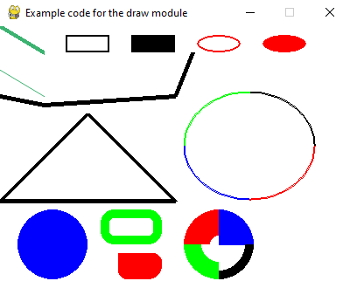
Example code for draw module.
import pygame
from math import pi

# Initialize pygame
pygame.init()

# Set the height and width of the screen
size = [400, 300]
screen = pygame.display.set_mode(size)

pygame.display.set_caption("Example code for the draw module")

# Loop until the user clicks the close button.
done = False
clock = pygame.time.Clock()

while not done:
# This limits the while loop to a max of 60 times per second.
# Leave this out and we will use all CPU we can.
clock.tick(60)

for event in pygame.event.get(): # User did something
if event.type == pygame.QUIT: # If user clicked close
done = True # Flag that we are done so we exit this loop

# Clear the screen and set the screen background
screen.fill("white")

# Draw on the screen a green line from (0, 0) to (50, 30)
# 5 pixels wide. Uses (r, g, b) color - medium sea green.
pygame.draw.line(screen, (60, 179, 113), [0, 0], [50, 30], 5)

# Draw on the screen a green line from (0, 50) to (50, 80)
# Because it is an antialiased line, it is 1 pixel wide.
# Uses (r, g, b) color - medium sea green.
pygame.draw.aaline(screen, (60, 179, 113), [0, 50], [50, 80], True)

# Draw on the screen 3 black lines, each 5 pixels wide.
# The 'False' means the first and last points are not connected.
pygame.draw.lines(
screen, "black", False, [[0, 80], [50, 90], [200, 80], [220, 30]], 5
)

# Draw a rectangle outline
pygame.draw.rect(screen, "black", [75, 10, 50, 20], 2)

# Draw a solid rectangle. Same color as "black" above, specified in a new way
pygame.draw.rect(screen, (0, 0, 0), [150, 10, 50, 20])

# Draw a rectangle with rounded corners
pygame.draw.rect(screen, "green", [115, 210, 70, 40], 10, border_radius=15)
pygame.draw.rect(
screen,
"red",
[135, 260, 50, 30],
0,
border_radius=10,
border_top_left_radius=0,
border_bottom_right_radius=15,
)

# Draw an ellipse outline, using a rectangle as the outside boundaries
pygame.draw.ellipse(screen, "red", [225, 10, 50, 20], 2)

# Draw an solid ellipse, using a rectangle as the outside boundaries
pygame.draw.ellipse(screen, "red", [300, 10, 50, 20])

# This draws a triangle using the polygon command
pygame.draw.polygon(screen, "black", [[100, 100], [0, 200], [200, 200]], 5)

# Draw an arc as part of an ellipse.
# Use radians to determine what angle to draw.
pygame.draw.arc(screen, "black", [210, 75, 150, 125], 0, pi / 2, 2)
pygame.draw.arc(screen, "green", [210, 75, 150, 125], pi / 2, pi, 2)
pygame.draw.arc(screen, "blue", [210, 75, 150, 125], pi, 3 * pi / 2, 2)
pygame.draw.arc(screen, "red", [210, 75, 150, 125], 3 * pi / 2, 2 * pi, 2)

# Draw a circle
pygame.draw.circle(screen, "blue", [60, 250], 40)

# Draw only one circle quadrant
pygame.draw.circle(screen, "blue", [250, 250], 40, 0, draw_top_right=True)
pygame.draw.circle(screen, "red", [250, 250], 40, 30, draw_top_left=True)
pygame.draw.circle(screen, "green", [250, 250], 40, 20, draw_bottom_left=True)
pygame.draw.circle(screen, "black", [250, 250], 40, 10, draw_bottom_right=True)

# Go ahead and update the screen with what we've drawn.
# This MUST happen after all the other drawing commands.
pygame.display.flip()

# Be IDLE friendly
pygame.quit()

draw.text
https://pygame-zero.readthedocs.io/en/stable/ptext.html

Positioning
screen.draw.text("hello world", centery=50, right=300)
screen.draw.text("hello world", midtop=(400, 0))
Keyword arguments:
top left bottom right
topleft bottomleft topright bottomright
midtop midleft midbottom midright
center centerx centery
Positioning keyword arguments behave like the corresponding properties of pygame.Rect. Either specify two arguments, corresponding to the horizontal and vertical positions of the box, or a single argument that specifies both.

Text alignment
screen.draw.text("hello\nworld", bottomright=(500, 400), align="left")
Keyword argument:
align: horizontal positioning of lines with respect to each other. Defaults to None.
align determines how lines are positioned horizontally with respect to each other, when more than one line is drawn. Valid values for align are the strings "left", "center", or "right", a numerical value between 0.0 (for left alignment) and 1.0 (for right alignment), or None.
If align is None, the alignment is determined based on other arguments, in a way that should be what you want most of the time. It depends on any positioning arguments (topleft, centerx, etc.), anchor, and finally defaults to "left". I suggest you generally trust the default alignment, and only specify align if something doesn’t look right.

sndArray
pygame.sndarray
pygame module for accessing sound sample data
pygame.sndarray.array | copy Sound samples into an array
pygame.sndarray.samples | reference Sound samples into an array
pygame.sndarray.make_sound | convert an array into a Sound object
pygame.sndarray.use_arraytype | Sets the array system to be used for sound arrays
pygame.sndarray.get_arraytype | Gets the currently active array type.
pygame.sndarray.get_arraytypes | Gets the array system types currently supported.
Functions to convert between NumPy arrays and Sound objects. This module will only be functional when pygame can use the external NumPy package. If NumPy can't be imported, surfarray becomes a MissingModule object.
Sound data is made of thousands of samples per second, and each sample is the amplitude of the wave at a particular moment in time. For example, in 22-kHz format, element number 5 of the array is the amplitude of the wave after 5/22000 seconds.
The arrays are indexed by the X axis first, followed by the Y axis. Each sample is an 8-bit or 16-bit integer, depending on the data format. A stereo sound file has two values per sample, while a mono sound file only has one.
pygame.sndarray.array()
copy Sound samples into an array
array(Sound) -> array
Creates a new array for the sound data and copies the samples. The array will always be in the format returned from pygame.mixer.get_init().
Top of Form
Bottom of Form
pygame.sndarray.samples()
reference Sound samples into an array
samples(Sound) -> array
Creates a new array that directly references the samples in a Sound object. Modifying the array will change the Sound. The array will always be in the format returned from pygame.mixer.get_init().
Top of Form
Bottom of Form
pygame.sndarray.make_sound()
convert an array into a Sound object
make_sound(array) -> Sound
Create a new playable Sound object from an array. The mixer module must be initialized and the array format must be similar to the mixer audio format.
Top of Form
Bottom of Form
pygame.sndarray.use_arraytype()
Sets the array system to be used for sound arrays
use_arraytype (arraytype) -> None
DEPRECATED: Uses the requested array type for the module functions. The only supported arraytype is 'numpy'. Other values will raise ValueError. Using this function will raise a DeprecationWarning. .. ## pygame.sndarray.use_arraytype ##
Top of Form
Bottom of Form
pygame.sndarray.get_arraytype()
Gets the currently active array type.
get_arraytype () -> str
DEPRECATED: Returns the currently active array type. This will be a value of the get_arraytypes() tuple and indicates which type of array module is used for the array creation. Using this function will raise a DeprecationWarning.
New in pygame 1.8.
Top of Form
Bottom of Form
pygame.sndarray.get_arraytypes()
Gets the array system types currently supported.
get_arraytypes () -> tuple
DEPRECATED: Checks, which array systems are available and returns them as a tuple of strings. The values of the tuple can be used directly in the pygame.sndarray.use_arraytype()Sets the array system to be used for sound arrays () method. If no supported array system could be found, None will be returned. Using this function will raise a DeprecationWarning.
New in pygame 1.8.
Top of Form
Bottom of Form

Edit on GitHub
- index
- modules |
- next |
- previous |
- pygame v2.6.0 documentation »

- pygame.sndarray

input box
https://www.geeksforgeeks.org/how-to-create-a-text-input-box-with-pygame/?ref=lbp

github
https://github.com/chrisking1981/Aider-AI-Arkanoid-with-Multiplayer/commit/d7248a9998fd2ec1035093534690d7c3045d9dde

vscode
Python: Default Interpreter Path
Path to default Python to use when extension loads up for the first time, no longer used once an interpreter is selected for the workspace. See (BELOW) to understand when this is used
https://code.visualstudio.com/docs/python/environments

Python workspace in VS Code
An "environment" in Python is the context in which a Python program runs that consists of an interpreter and any number of installed packages.
Link to Python environments, details below:

Types of Python environments

Global environments
By default, any Python interpreter installed runs in its own global environment. For example, if you just run python, python3, or py at a new terminal (depending on how you installed Python), you're running in that interpreter's global environment. Any packages that you install or uninstall affect the global environment and all programs that you run within it.
best practice: create a workspace-specific environment, for example, by using a local environment.

Local environments
There are two types of environments that you can create for your workspace: virtual and Conda. These environments allow you to install packages without affecting other environments, isolating your workspace's package installations.

Virtual environments
A virtual environment is a built-in way to create an environment. A virtual environment creates a folder that contains a copy (or symlink) to a specific interpreter. When you install packages into a virtual environment it will end up in this new folder, and thus isolated from other packages used by other workspaces.
Note: While it's possible to open a virtual environment folder as a workspace, doing so is not recommended and might cause issues with using the Python extension.

Conda environments
A Conda environment is a Python environment that's managed using the Conda package manager (see Getting started with Conda).Choosing between Conda and virtual environments depends on your packaging needs, team standards, etc.

Python environment tools
The following table lists the various tools involved with Python environments:
Tool | Definition and Purpose
pip | The Python package manager that installs and updates packages. It's installed with Python 3.9+ by default (unless you are on a Debian-based OS; install python3-pip in that case).
venv | Allows you to manage separate package installations for different projects and is installed with Python 3 by default (unless you are on a Debian-based OS; install python3-venv in that case)
Conda | Installed with Miniconda. It can be used to manage both packages and virtual environments. Generally used for data science projects.

Creating environments

Using the Create Environment command
To create local environments in VS Code using virtual environments or Anaconda, you can follow these steps: open the Command Palette (⇧⌘P), search for the Python: Create Environment command, and select it.
The command presents a list of environment types: Venv or Conda.
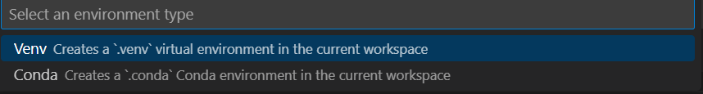
If you are creating an environment using Venv, the command presents a list of interpreters that can be used as a base for the new virtual environment.
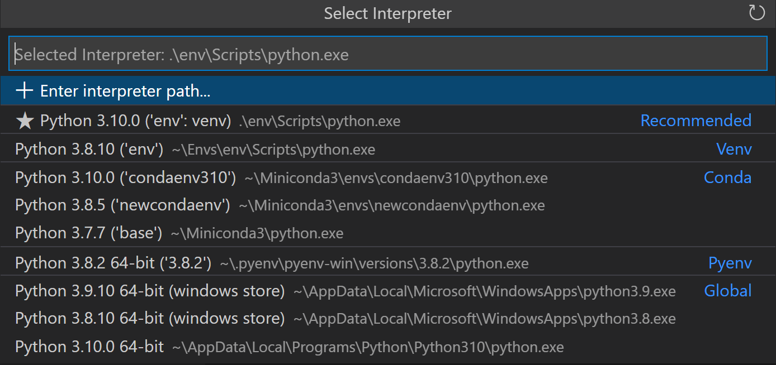
If you are creating an environment using Conda, the command presents a list of Python versions that can be used for your project.
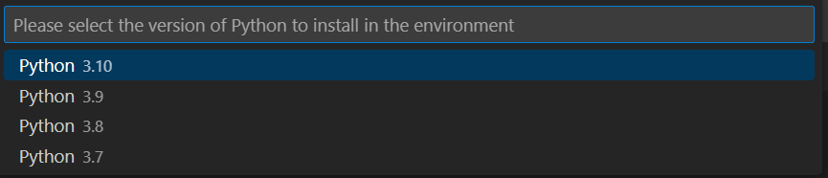
After selecting the desired interpreter or Python version, a notification will show the progress of the environment creation and the environment folder will appear in your workspace.
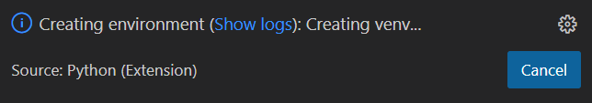
Note: The command will also install necessary packages outlined in a requirements/dependencies file, such as requirements.txt, pyproject.toml, or environment.yml, located in the project folder. It will also add a .gitignore file to the virtual environment to help prevent you from accidentally committing the virtual environment to source control.

Create a virtual environment in the terminal
If you choose to create a virtual environment manually, use the following command (where ".venv" is the name of the environment folder):
# macOS/Linux
# You may need to run `sudo apt-get install python3-venv` first on Debian-based OSs
python3 -m venv .venv

# Windows
# You can also use `py -3 -m venv .venv`
python -m venv .venv
Copy
Note: To learn more about the venv module, read Creation of virtual environments on Python.org.
When you create a new virtual environment, a prompt will be displayed in VS Code to allow you to select it for the workspace.
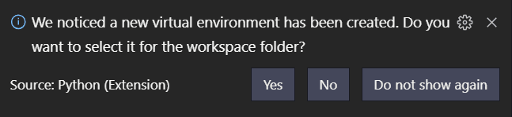
Tip: Make sure to update your source control settings to prevent accidentally committing your virtual environment (in for example .gitignore). Since virtual environments are not portable, it typically does not make sense to commit them for others to use.

Create a Conda environment in the terminal
The Python extension automatically detects existing Conda environments. We recommend you install a Python interpreter into your Conda environment, otherwise one will be installed for you after you select the environment. For example, the following command creates a Conda environment named env-01 with a Python 3.9 interpreter and several libraries:
Conda create -n env-01 python=3.9 scipy=0.15.0 numpy
Copy
Note: For more information on the Conda command line, you can read Conda environments.
Additional notes:
- If you create a new Conda environment while VS Code is running, use the refresh icon on the top right of the Python: Select Interpreter window; otherwise you may not find the environment there.
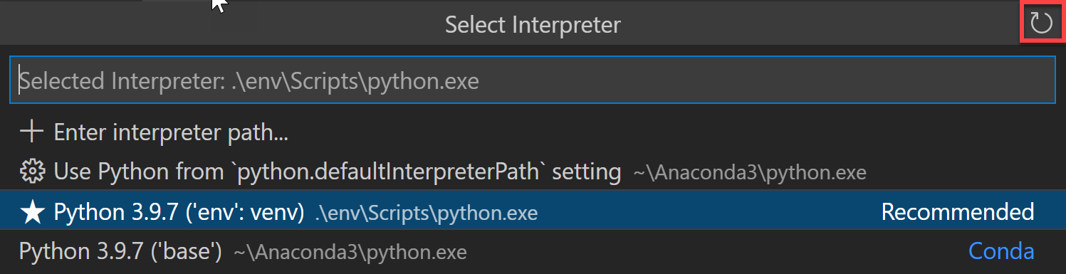
- To ensure the environment is properly set up from a shell perspective, use an Anaconda prompt and activate the desired environment. Then, you can launch VS Code by entering the code . command. Once VS Code is open, you can select the interpreter either by using the Command Palette or by clicking on the status bar.
- Although the Python extension for VS Code doesn't currently have direct integration with Conda environment.yml files, VS Code itself is a great YAML editor.
- Conda environments can't be automatically activated in the VS Code Integrated Terminal if the default shell is set to PowerShell. To change the shell, see Integrated terminal - Terminal profiles.
- You can manually specify the path to the Conda executable to use for activation (version 4.4+). To do so, open the Command Palette (⇧⌘P) and run Preferences: Open User Settings. Then set python.condaPath, which is in the Python extension section of User Settings, with the appropriate path.

Working with Python interpreters

Select and activate an environment
The Python extension tries to find and then select what it deems the best environment for the workspace. If you would prefer to select a specific environment, use the Python: Select Interpreter command from the Command Palette (⇧⌘P).
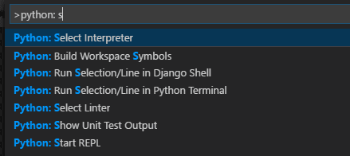
Note: If the Python extension doesn't find an interpreter, it issues a warning. On macOS 12.2 and older, the extension also issues a warning if you're using the OS-installed Python interpreter as it is known to have compatibility issues. In either case, you can disable these warnings by setting python.disableInstallationCheck to true in your user settings.
The Python: Select Interpreter command displays a list of available global environments, Conda environments, and virtual environments. (See the Where the extension looks for environments section for details, including the distinctions between these types of environments.) The following image, for example, shows several Anaconda and CPython installations along with a Conda environment and a virtual environment (env) that's located within the workspace folder:
Note: On Windows, it can take a little time for VS Code to detect available Conda environments. During that process, you may see "(cached)" before the path to an environment. The label indicates that VS Code is presently working with cached information for that environment.
If you have a folder or a workspace open in VS Code and you select an interpreter from the list, the Python extension will store that information internally. This ensures that the same interpreter will be used when you reopen the workspace.
The selected environment is used by the Python extension for running Python code (using the Python: Run Python File in Terminal command), providing language services (auto-complete, syntax checking, linting, formatting, etc.) when you have a .py file open in the editor, and opening a terminal with the Terminal: Create New Terminal command. In the latter case, VS Code automatically activates the selected environment.
Tip: To prevent automatic activation of a selected environment, add "python.terminal.activateEnvironment": false to your settings.json file (it can be placed anywhere as a sibling to the existing settings).
Tip: If the activate command generates the message "Activate.ps1 is not digitally signed. You cannot run this script on the current system.", then you need to temporarily change the PowerShell execution policy to allow scripts to run (see About Execution Policies in the PowerShell documentation): Set-ExecutionPolicy -ExecutionPolicy RemoteSigned -Scope Process
Note: By default, VS Code uses the interpreter selected for your workspace when debugging code. You can override this behavior by specifying a different path in the python property of a debug configuration. See Choose a debugging environment.
The selected interpreter version will show on the right side of the Status Bar.
The Status Bar also reflects when no interpreter is selected.
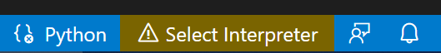
In either case, clicking this area of the Status Bar is a convenient shortcut for the Python: Select Interpreter command.
Tip: If you have any problems with VS Code recognizing a virtual environment, please file an issue so we can help determine the cause.

Manually specify an interpreter
If VS Code doesn't automatically locate an interpreter you want to use, you can browse for the interpreter on your file system or provide the path to it manually.
You can do so by running the Python: Select Interpreter command and select the Enter interpreter path... option that shows on the top of the interpreters list:
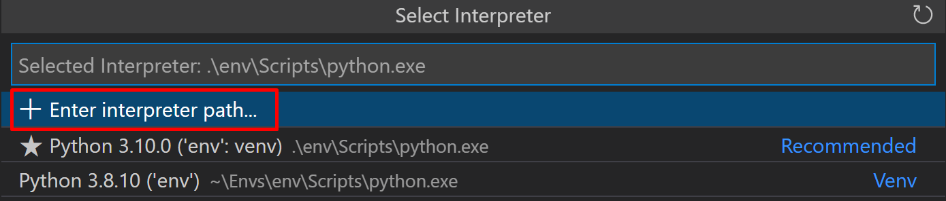
You can then either enter the full path of the Python interpreter directly in the text box (for example, ".venv/Scripts/python.exe"), or you can select the Find... button and browse your file system to find the python executable you wish to select.
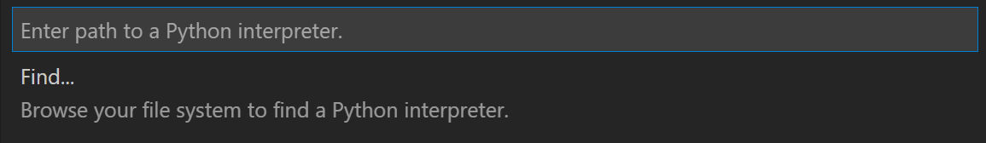
If you want to manually specify a default interpreter that will be used when you first open your workspace, you can create or modify an entry for the python.defaultInterpreterPath setting.
Note: Changes to the python.defaultInterpreterPath setting are not picked up after an interpreter has already been selected for a workspace; any changes to the setting will be ignored once an initial interpreter is selected for the workspace.
Additionally, if you'd like to set up a default interpreter to all of your Python applications, you can add an entry for python.defaultInterpreterPath manually inside your User Settings. To do so, open the Command Palette (⇧⌘P) and enter Preferences: Open User Settings. Then set python.defaultInterpreterPath, which is in the Python extension section of User Settings, with the appropriate interpreter.

How the extension chooses an environment automatically
If an interpreter hasn't been specified, then the Python extension automatically selects the interpreter with the highest version in the following priority order:
- Virtual environments located directly under the workspace folder.
- Virtual environments related to the workspace but stored globally. For example, Pipenv or Poetry environments that are located outside of the workspace folder.
- Globally installed interpreters. For example, the ones found in /usr/local/bin, C:\\python38, etc.
Note: The interpreter selected may differ from what python refers to in your terminal.
If Visual Studio Code doesn't locate your interpreter automatically, you can manually specify an interpreter.

Where the extension looks for environments
The extension automatically looks for interpreters in the following locations, in no particular order:
- Standard install paths such as /usr/local/bin, /usr/sbin, /sbin, c:\\python36, etc.
- Virtual environments located directly under the workspace (project) folder.
- Virtual environments located in the folder identified by the python.venvPath setting (see General Python settings), which can contain multiple virtual environments. The extension looks for virtual environments in the first-level subfolders of venvPath.
- Virtual environments located in a ~/.virtualenvs folder for virtualenvwrapper.
- Interpreters created by pyenv, Pipenv, and Poetry.
- Virtual environments located in the path identified by WORKON_HOME (as used by virtualenvwrapper).
- Conda environments found by Conda env list. Conda environments which do not have an interpreter will have one installed for them upon selection.
- Interpreters installed in a .direnv folder for direnv under the workspace folder.

Environments and Terminal windows
After using Python: Select Interpreter, that interpreter is applied when right-clicking a file and selecting Python: Run Python File in Terminal. The environment is also activated automatically when you use the Terminal: Create New Terminal command unless you change the python.terminal.activateEnvironment setting to false.
Please note that launching VS Code from a shell in which a specific Python environment is activated doesn't automatically activate that environment in the default Integrated Terminal.
Note: Conda environments cannot be automatically activated in the integrated terminal if PowerShell is set as the integrated shell. See Integrated terminal - Terminal profiles for how to change the shell.
Changing interpreters with the Python: Select Interpreter command doesn't affect terminal panels that are already open. Thus, you can activate separate environments in a split terminal: select the first interpreter, create a terminal for it, select a different interpreter, then use the split button (⌘\) in the terminal title bar.

Choose a debugging environment
By default, the debugger will use the Python interpreter chosen with the Python extension. However, if there is a python property specified in the debug configuration of launch.json, it takes precedence. If this property is not defined, it will fall back to using the Python interpreter path selected for the workspace.
For more details on debug configuration, see Debugging configurations.

Environment variables

Environment variable definitions file
An environment variable definitions file is a text file containing key-value pairs in the form of environment_variable=value, with # used for comments. Multiline values aren't supported, but references to previously defined environment variables are allowed. Environment variable definitions files can be used for scenarios such as debugging and tool execution (including linters, formatters, IntelliSense, and testing tools), but aren't applied to the terminal.
Note: Environment variable definitions files are not necessarily cross-platform. For instance, while Unix uses : as a path separator in environment variables, Windows uses ;. There is no normalization of such operating system differences, and so you need to make sure any environment definitions file use values that are compatible with your operating system.
By default, the Python extension looks for and loads a file named .env in the current workspace folder, then applies those definitions. The file is identified by the default entry "python.envFile": "${workspaceFolder}/.env" in your user settings (see General Python settings). You can change the python.envFile setting at any time to use a different definitions file.
Note: Environment variable definitions files are not used in all situations where environment variables are available for use. Unless Visual Studio Code documentation states otherwise, these only affect certain scenarios as per their definition. For example, the extension doesn't use environment variable definitions files when resolving setting values.
A debug configuration also contains an envFile property that also defaults to the .env file in the current workspace (see Debugging - Set configuration options). This property allows you to easily set variables for debugging purposes that replace variables specified in the default .env file.
For example, when developing a web application, you might want to easily switch between development and production servers. Instead of coding the different URLs and other settings into your application directly, you could use separate definitions files for each. For example:
dev.env file
# dev.env - development configuration

# API endpoint
MYPROJECT_APIENDPOINT=https://my.domain.com/api/dev/

# Variables for the database
MYPROJECT_DBURL=https://my.domain.com/db/dev
MYPROJECT_DBUSER=devadmin
MYPROJECT_DBPASSWORD=!dfka**213=
Copy
prod.env file
# prod.env - production configuration

# API endpoint
MYPROJECT_APIENDPOINT=https://my.domain.com/api/

# Variables for the database
MYPROJECT_DBURL=https://my.domain.com/db/
MYPROJECT_DBUSER=coreuser
MYPROJECT_DBPASSWORD=kKKfa98*11@
Copy
You can then set the python.envFile setting to ${workspaceFolder}/prod.env, then set the envFile property in the debug configuration to ${workspaceFolder}/dev.env.
Note: When environment variables are specified using multiple methods, be aware that there is an order of precedence. All env variables defined in the launch.json file will override variables contained in the .env file, specified by the python.envFile setting (user or workspace). Similarly, env variables defined in the launch.json file will override the environment variables defined in the envFile that are specified in launch.json.

Use of the PYTHONPATH variable
The PYTHONPATH environment variable specifies additional locations where the Python interpreter should look for modules. In VS Code, PYTHONPATH can be set through the terminal settings (terminal.integrated.env.*) and/or within an .env file.
When the terminal settings are used, PYTHONPATH affects any tools that are run within the terminal by a user, as well as any action the extension performs for a user that is routed through the terminal such as debugging. However, in this case when the extension is performing an action that isn't routed through the terminal, such as the use of a linter or formatter, then this setting won't have an effect on module look-up.

Next steps
- Editing code - Learn about autocomplete, IntelliSense, formatting, and refactoring for Python.
- Debugging - Learn to debug Python both locally and remotely.
- Testing - Configure test environments and discover, run, and debug tests.
- Settings reference - Explore the full range of Python-related settings in VS Code.

More Python resources
- Getting Started with Python in VS Code - Learn how to edit, run, and debug code in VS Code.
- Virtual Environments and Packages (Python.org) - Learn more about virtual environments and packages.
- Installing Python Modules (Python.org) - Learn how to install Python modules.
- Python tutorial (Python.org) -

Python debugging in VS Code
The Python extension supports debugging through the Python Debugger extension for several types of Python applications. For a short walkthrough of basic debugging, see Tutorial - Configure and run the debugger. Also see the Flask tutorial. Both tutorials demonstrate core skills like setting breakpoints and stepping through code.
For general debugging features such as inspecting variables, setting breakpoints, and other activities that aren't language-dependent, review VS Code debugging.
This article mainly addresses Python-specific debugging configurations, including the necessary steps for specific app types and remote debugging.

Python Debugger Extension
The Python Debugger extension is automatically installed along with the Python extension for VS Code. It offers debugging features with debugpy for several types of Python applications, including scripts, web apps, remote processes and more.
To verify it's installed, open the Extensions view (⇧⌘X) and search for @installed python debugger. You should see the Python Debugger extension listed in the results.
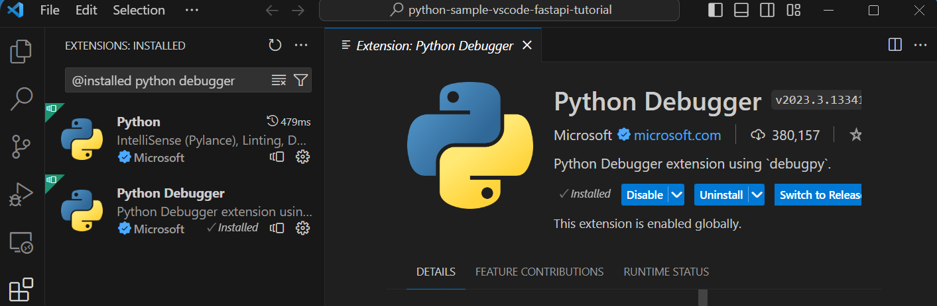
You can refer to the extension's README page for information on supported Python versions.

Initialize configurations
A configuration drives VS Code's behavior during a debugging session. Configurations are defined in a launch.json file that's stored in a .vscode folder in your workspace.
Note: To change debugging configuration, your code must be stored in a folder.
To initialize debug configurations, first select the Run view in the sidebar:
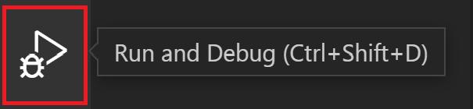
If you don't yet have any configurations defined, you'll see a button to Run and Debug and a link to create a configuration (launch.json) file:
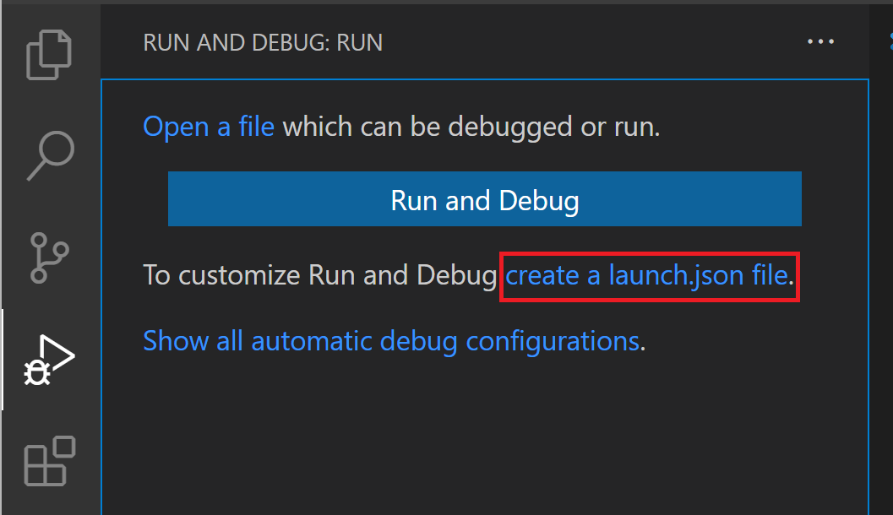
To generate a launch.json file with Python configurations, do the following steps:
- Select the create a launch.json file link (outlined in the image above) or use the Run > Open configurations menu command.
- Select Python Debugger from the debugger options list.
- A configuration menu will open from the Command Palette allowing you to choose the type of debug configuration you want to use for our Python project file. If you want to debug a single Python script, select Python File in the Select a debug configuration menu that appears.
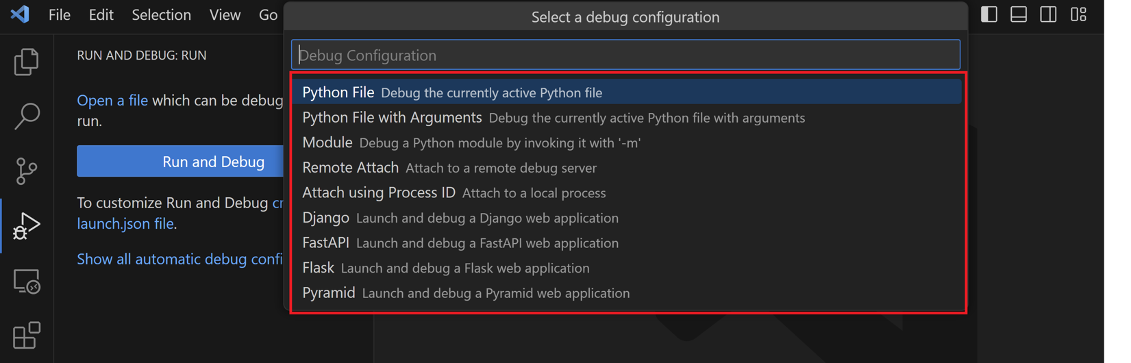
Note: Starting a debugging session through the Debug Panel, F5, or Run > Start Debugging when no configuration exists will also bring up the debug configuration menu, but will not create a launch.json file.
- The Python Debugger extension then creates and opens a launch.json file that contains a pre-defined configuration based on what you previously selected, in this case, Python File. You can modify configurations (to add arguments, for example), and also add custom configurations.
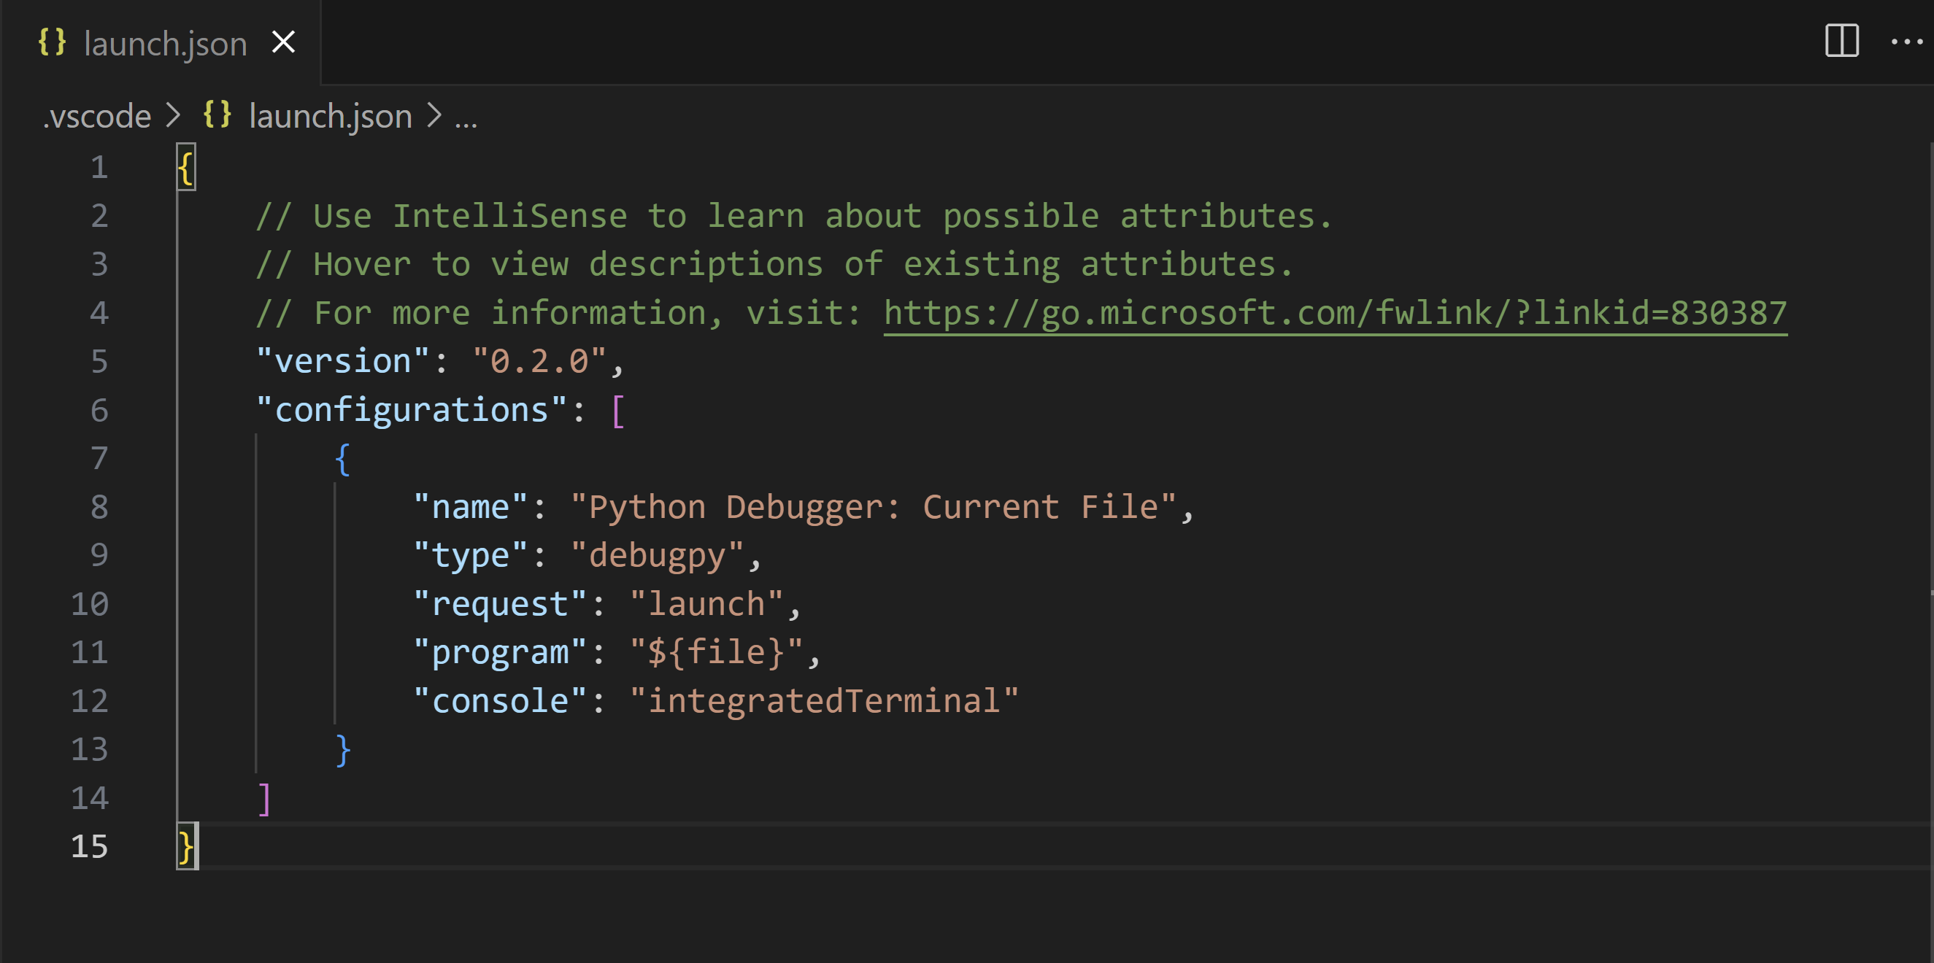
The details of configuration properties are covered later in this article under Standard configuration and options. Other configurations are also described in this article under Debugging specific app types.

Additional configurations
By default, VS Code shows only the most common configurations provided by the Python Debugger extension. You can select other configurations to include in launch.json by using the Add Configuration command shown in the list and the launch.json editor. When you use the command, VS Code prompts you with a list of all available configurations (be sure to select the Python option):
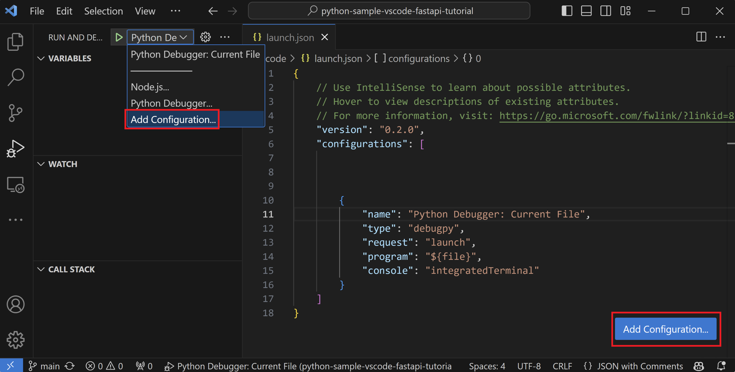
Selecting the Attach using Process ID one yields the following result: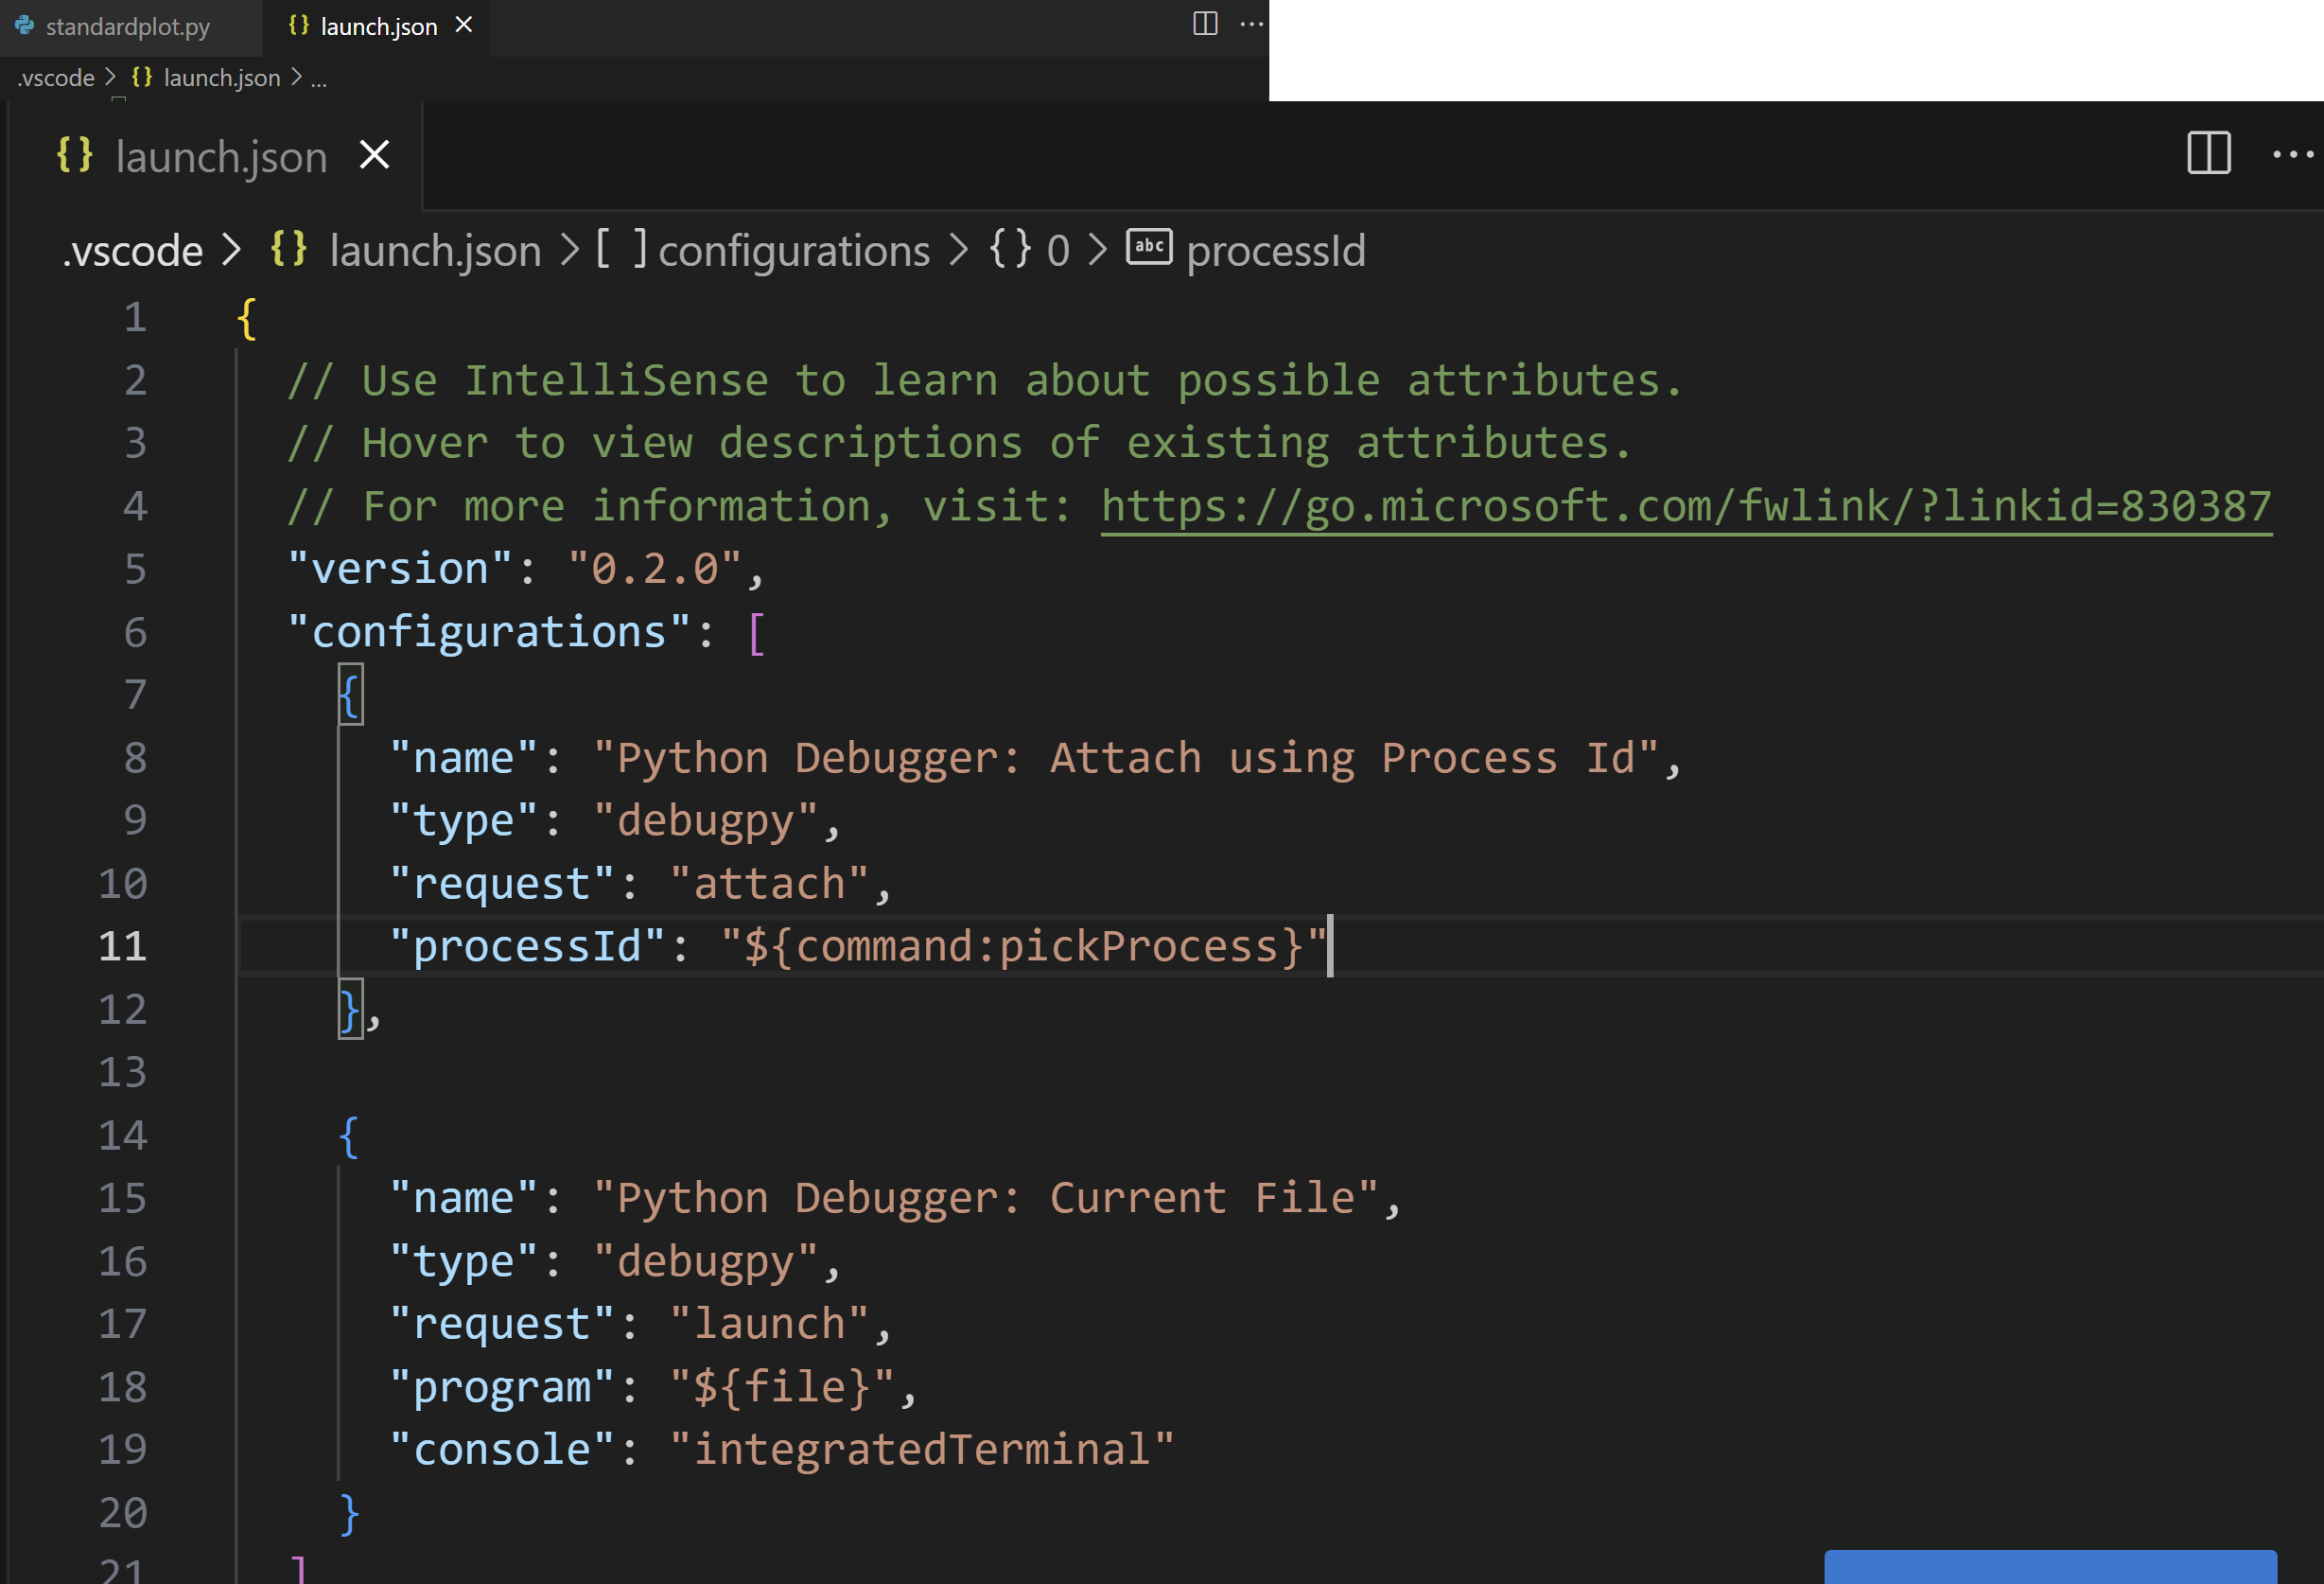
See Debugging specific app types for details on all of these configurations.
During debugging, the Status Bar shows the current configuration and the current debugging interpreter. Selecting the configuration brings up a list from which you can choose a different configuration:
By default, the debugger uses the same interpreter selected for your workspace, just like other features of Python extension for VS Code. To use a different interpreter for debugging specifically, set the value for python in launch.json for the applicable debugger configuration. Alternately, use the Python interpreter indicator on the Status Bar to select a different one.

Basic debugging
If you're only interested in debugging a Python script, the simplest way is to select the down-arrow next to the run button on the editor and select Python Debugger: Debug Python File.
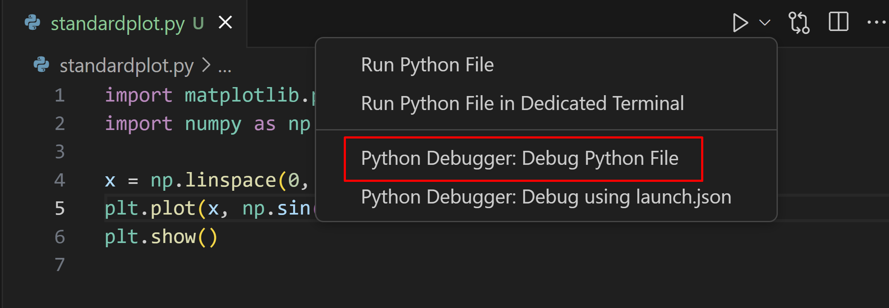
If you're looking to debug a web application using Flask, Django or FastAPI, the Python Debugger extension provides dynamically created debug configurations based on your project structure under the Show all automatic debug configurations option, through the Run and Debug view.
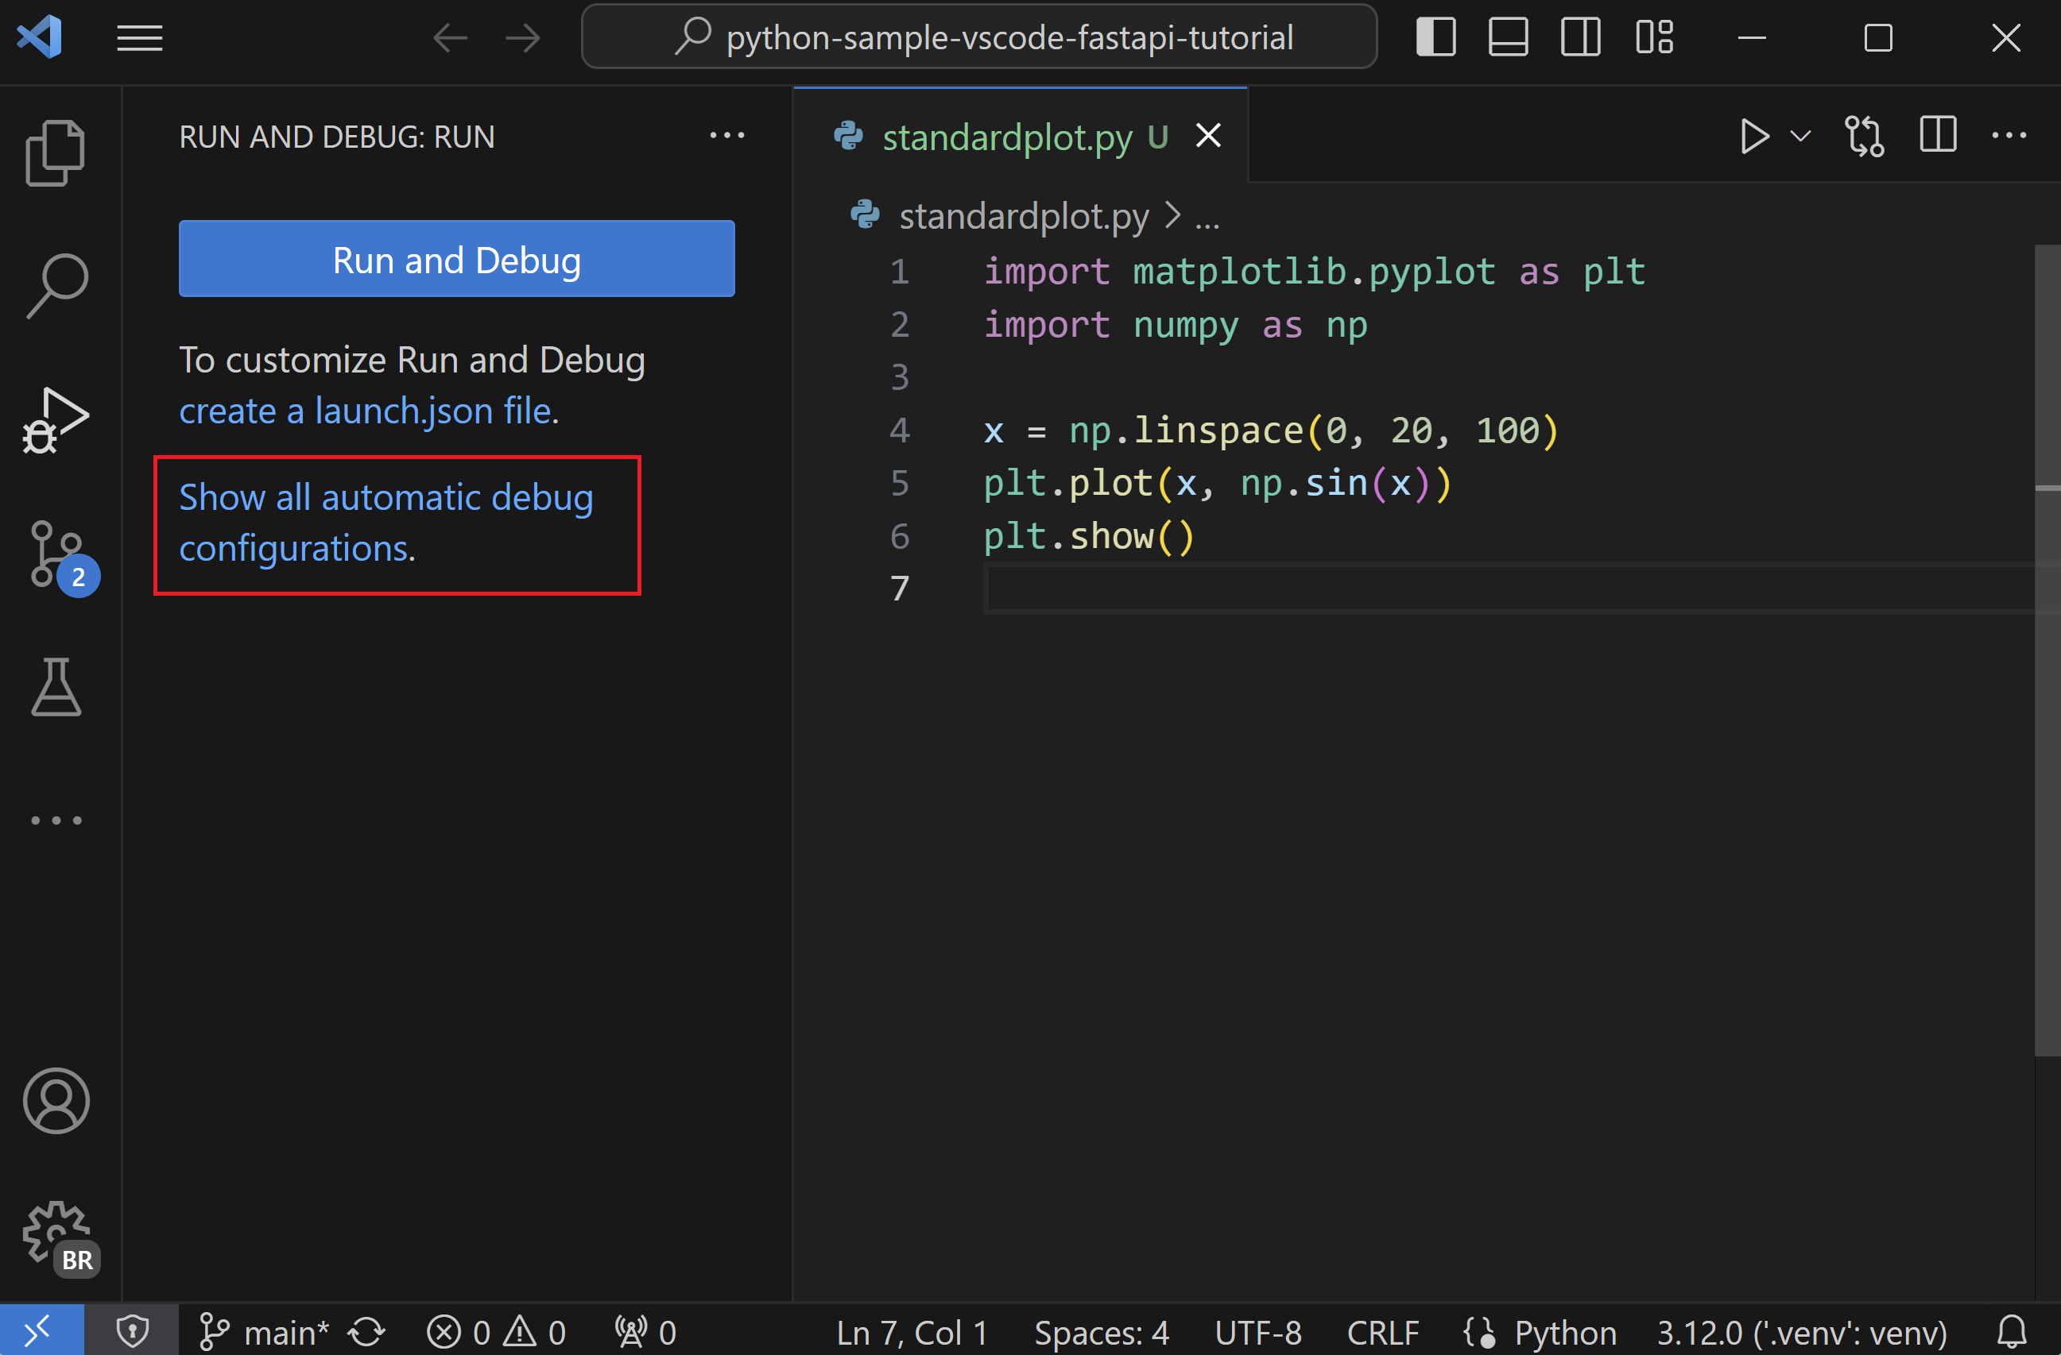
But if you're looking to debug other kinds of applications, you can start the debugger through the Run view by clicking on the Run and Debug button.
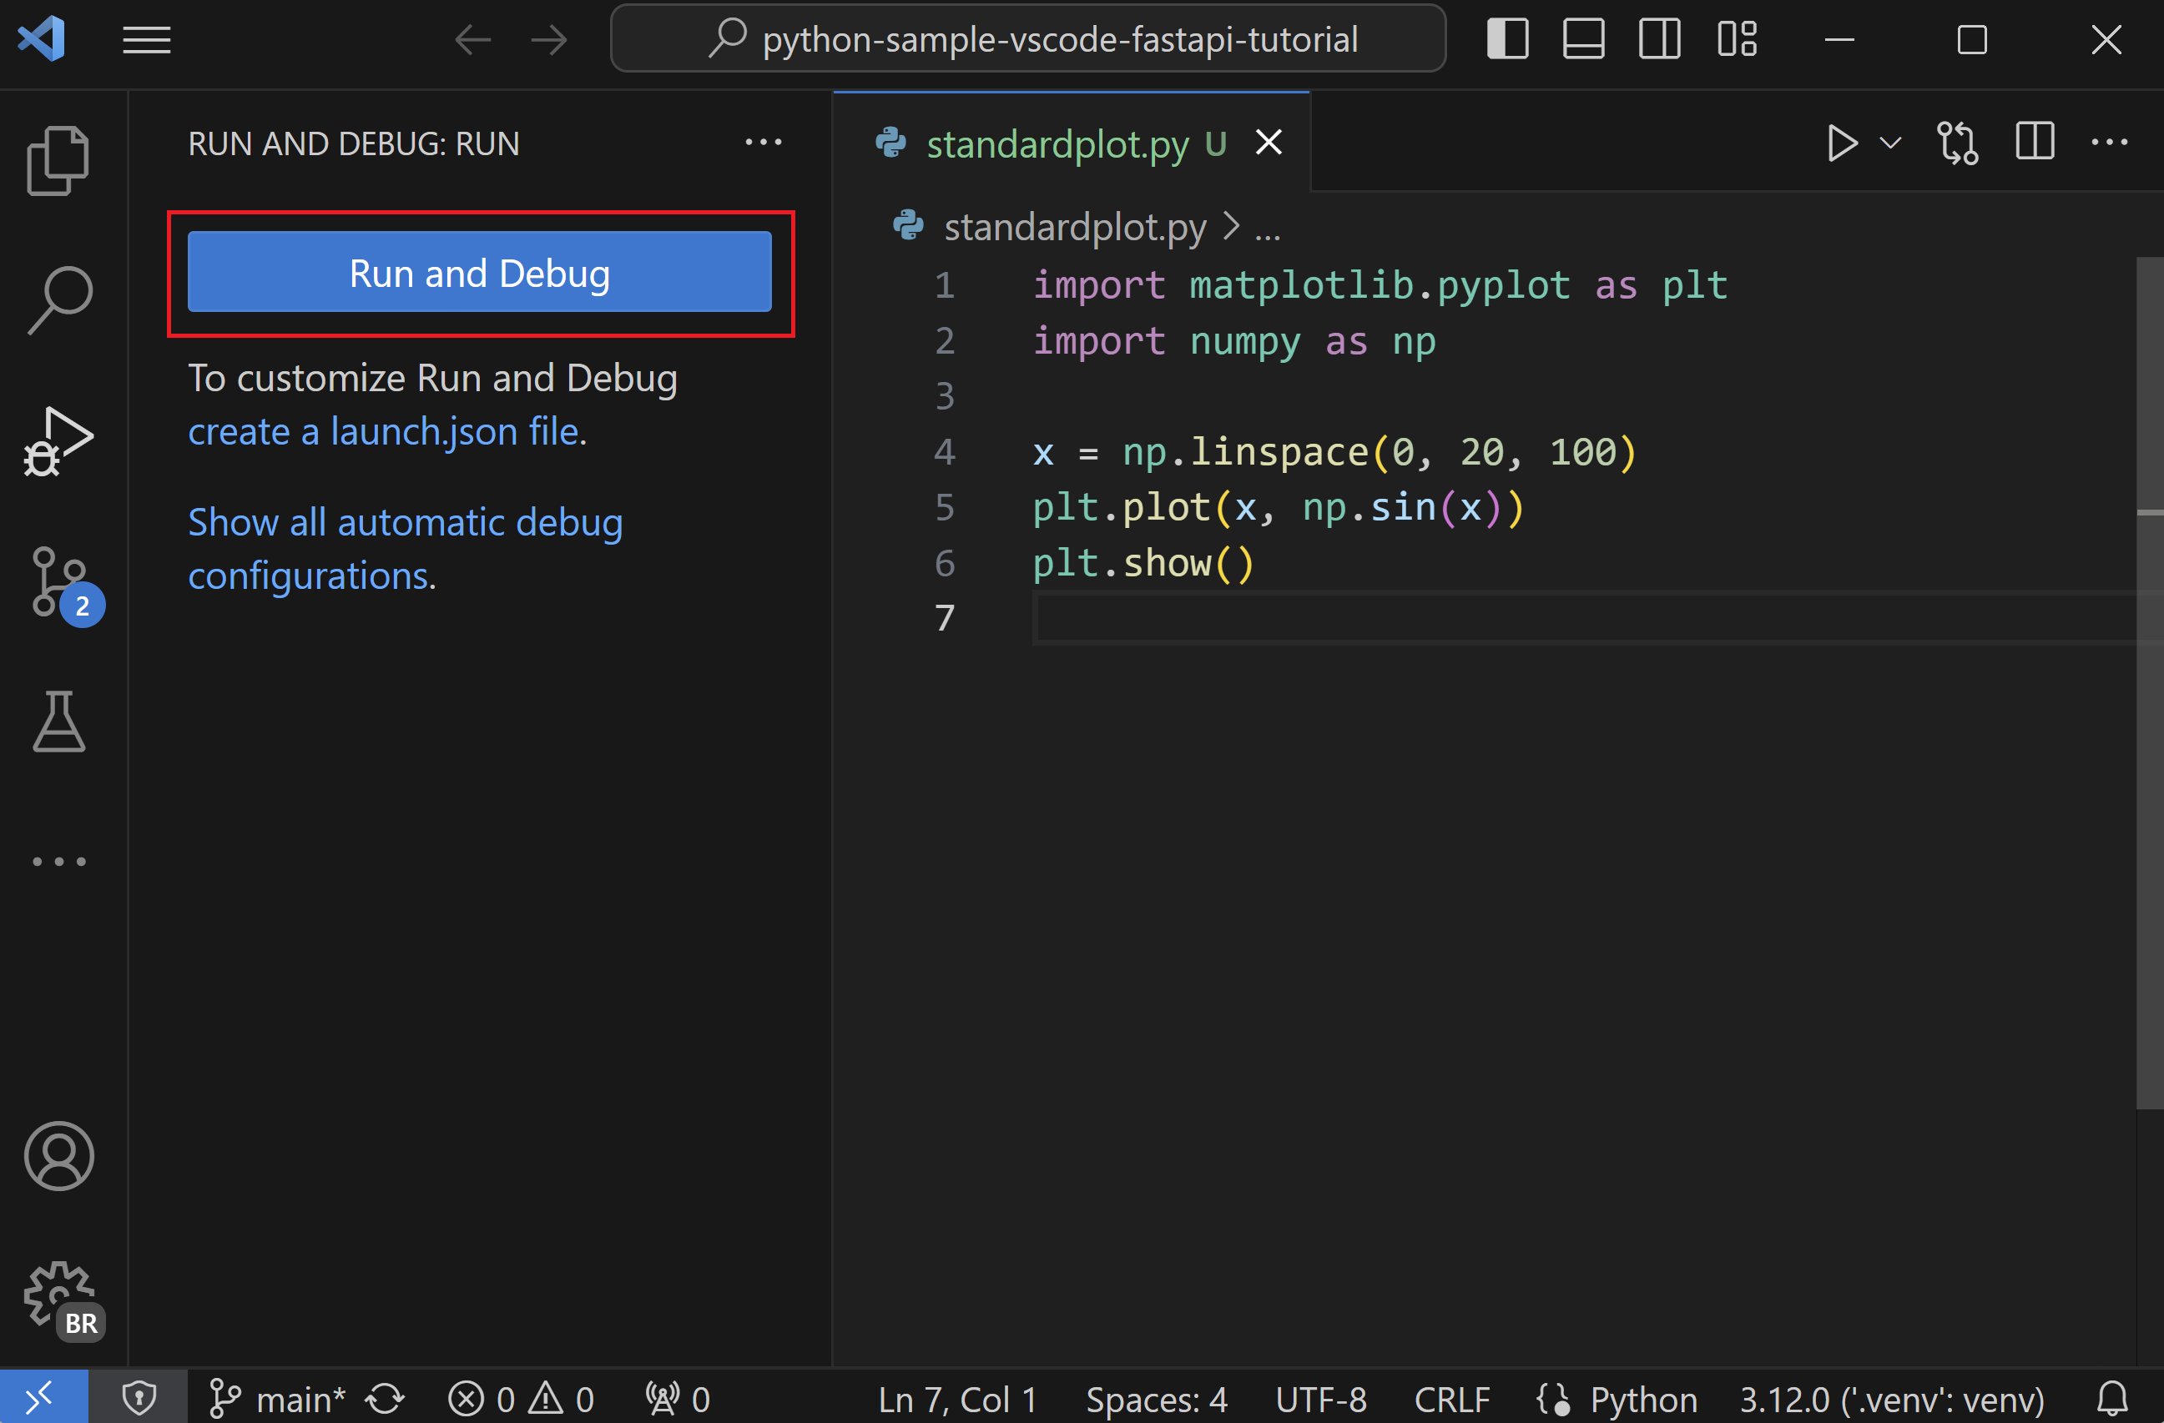
When no configuration has been set, you'll be given a list of debugging options. Here, you can select the appropriate option to quickly debug your code.
Two common options are to use the Python File configuration to run the currently open Python file or to use the Attach using Process ID configuration to attach the debugger to a process that is already running.
For information about creating and using debugging configurations, see the Initialize configurations and Additional configurations sections. Once a configuration is added, it can be selected from the dropdown list and started using the Start Debugging button (F5).
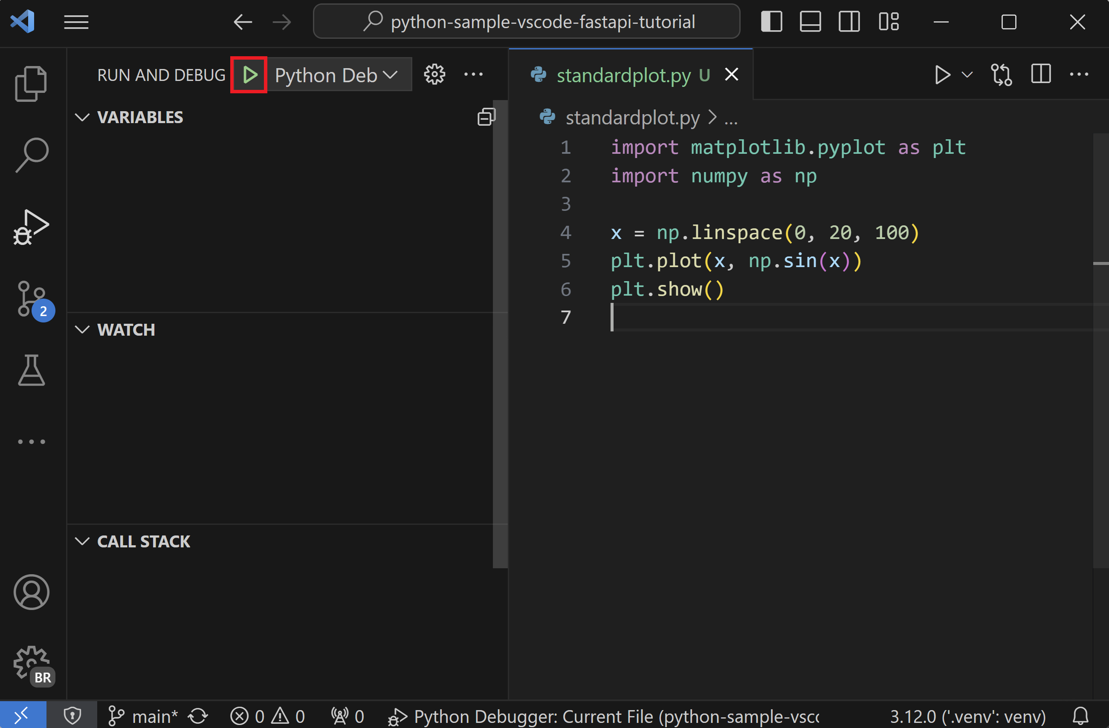

Command line debugging
The debugger can also be run from the command line, if debugpy is installed in your Python environment.

Install debugpy
You can install debugpy using python -m pip install --upgrade debugpy into your Python environment.
Tip: While using a virtual environment is not required, it is a recommended best practice. You can create a virtual environment in VS Code by opening the Command Palette (⇧⌘P) and running the Python: Create Virtual Environment command (unassigned).

Command line syntax
The debugger command line syntax is as follows:
python -m debugpy
--listen | --connect
[<host>:]<port>
[--wait-for-client]
[--configure-<name> <value>]...
[--log-to <path>] [--log-to-stderr]
<filename> | -m <module> | -c <code> | --pid <pid>
[<arg>]...
Copy

Example
From the command line, you could start the debugger using a specified port (5678) and script using the following syntax. This example assumes the script is long-running and omits the --wait-for-client flag, meaning that the script will not wait for the client to attach.
python -m debugpy --listen 5678 ./myscript.py
Copy
You would then use the following configuration to attach from the VS Code Python Debugger extension.
{
"name": "Python Debugger: Attach",
"type": "debugpy",
"request": "attach",
"connect": {
"host": "localhost",
"port": 5678
}
}
Copy
Note: Specifying host is optional for listen, by default 127.0.0.1 is used.
If you wanted to debug remote code or code running in a docker container, on the remote machine or container, you would need to modify the previous CLI command to specify a host.
python -m debugpy --listen 0.0.0.0:5678 ./myscript.py
Copy
The associated configuration file would then look as follows.
{
"name": "Attach",
"type": "debugpy",
"request": "attach",
"connect": {
"host": "remote-machine-name", // replace this with remote machine name
"port": 5678
}
}
Copy
Note: Be aware that when you specify a host value other than 127.0.0.1 or localhost you are opening a port to allow access from any machine, which carries security risks. You should make sure that you're taking appropriate security precautions, such as using SSH tunnels, when doing remote debugging.

Command line options
Flag | Options | Description
--listen or --connect | [<host>:]<port> | Required. Specifies the host address and port for the debug adapter server to wait for incoming connections (--listen) or to connect with a client that is waiting for an incoming connection (--connect). This is the same address that is used in the VS Code debug configuration. By default, the host address is localhost (127.0.0.1).
--wait-for-client | none | Optional. Specifies that the code should not run until there's a connection from the debug server. This setting allows you to debug from the first line of your code.
--log-to | <path> | Optional. Specifies a path to an existing directory for saving logs.
--log-to-stderr | none | Optional. Enables debugpy to write logs directly to stderr.
--pid | <pid> | Optional. Specifies a process that is already running to inject the debug server into.
--configure-<name> | <value> | Optional. Sets a debug property that must be known to the debug server before the client connects. Such properties can be used directly in launch configuration, but must be set in this manner for attach configurations. For example, if you don't want the debug server to automatically inject itself into subprocesses created by the process you're attaching to, use --configure-subProcess false.
Note: [<arg>] can be used to pass command-line arguments along to the app being launched.

Debugging by attaching over a network connection

Local script debugging
There may be instances where you need to debug a Python script that's invoked locally by another process. For example, you may be debugging a web server that runs different Python scripts for specific processing jobs. In such cases, you need to attach the VS Code debugger to the script once it's been launched:
- Run VS Code, open the folder or workspace containing the script, and create a launch.json for that workspace if one doesn't exist already.
- In the script code, add the following and save the file:
- import debugpy

- # 5678 is the default attach port in the VS Code debug configurations. Unless a host and port are specified, host defaults to 127.0.0.1
- debugpy.listen(5678)
- print("Waiting for debugger attach")
- debugpy.wait_for_client()
- debugpy.breakpoint()
- print('break on this line')
Copy
- Open a terminal using Terminal: Create New Terminal, which activates the script's selected environment.
- In the terminal, install the debugpy package.
- In the terminal, start Python with the script, for example, python3 myscript.py. You should see the "Waiting for debugger attach" message that's included in the code, and the script halts at the debugpy.wait_for_client() call.
- Switch to the Run and Debug view (⇧⌘D), select the appropriate configuration from the debugger dropdown list, and start the debugger.
- The debugger should stop on the debugpy.breakpoint() call, from which point you can use the debugger normally. You also have the option of setting other breakpoints in the script code using the UI instead of using debugpy.breakpoint().

Remote script debugging with SSH
Remote debugging allows you to step through a program locally within VS Code while it runs on a remote computer. It is not necessary to install VS Code on the remote computer. For added security, you may want or need to use a secure connection, such as SSH, to the remote computer when debugging.
Note: On Windows computers, you may need to install Windows 10 OpenSSH to have the ssh command.
The following steps outline the general process to set up an SSH tunnel. An SSH tunnel allows you to work on your local machine as if you were working directly on the remote in a more secure manner than if a port was opened for public access.
On the remote computer:
- Enable port forwarding by opening the sshd_config config file (found under /etc/ssh/ on Linux and under %programfiles(x86)%/openssh/etc on Windows) and adding or modifying the following setting:
- AllowTcpForwarding yes
Copy
Note: The default for AllowTcpForwarding is yes, so you might not need to make a change.
- If you had to add or modify AllowTcpForwarding, restart the SSH server. On Linux/macOS, run sudo service ssh restart; on Windows, run services.msc, select OpenSSH or sshd in the list of services, and select Restart.
On the local computer:
- Create an SSH tunnel by running ssh -2 -L sourceport:localhost:destinationport -i identityfile user@remoteaddress, using a selected port for destinationport and the appropriate username and the remote computer's IP address in user@remoteaddress. For example, to use port 5678 on IP address 1.2.3.4, the command would be ssh -2 -L 5678:localhost:5678 -i identityfile user@1.2.3.4. You can specify the path to an identity file, using the -i flag.
- Verify that you can see a prompt in the SSH session.
- In your VS Code workspace, create a configuration for remote debugging in your launch.json file, setting the port to match the port used in the ssh command and the host to localhost. You use localhost here because you've set up the SSH tunnel.
- {
- "name": "Python Debugger: Attach",
- "type": "debugpy",
- "request": "attach",
- "port": 5678,
- "host": "localhost",
- "pathMappings": [
- {
- "localRoot": "${workspaceFolder}", // Maps C:\Users\user1\project1
- "remoteRoot": "." // To current working directory ~/project1
- }
- ]
- }
Copy
Starting debugging
Now that an SSH tunnel has been set up to the remote computer, you can begin your debugging.
- Both computers: make sure that identical source code is available.
- Both computers: install debugpy.
- Remote computer: there are two ways to specify how to attach to the remote process.
  - In the source code, add the following lines, replacing address with the remote computer's IP address and port number (IP address 1.2.3.4 is shown here for illustration only).
  - import debugpy

  - # Allow other computers to attach to debugpy at this IP address and port.
  - debugpy.listen(('1.2.3.4', 5678))

  - # Pause the program until a remote debugger is attached
  - debugpy.wait_for_client()
Copy
The IP address used in listen should be the remote computer's private IP address. You can then launch the program normally, causing it to pause until the debugger attaches.
  - Launch the remote process through debugpy, for example:
  - python3 -m debugpy --listen 1.2.3.4:5678 --wait-for-client -m myproject
Copy
This starts the package myproject using python3, with the remote computer's private IP address of 1.2.3.4 and listening on port 5678 (you can also start the remote Python process by specifying a file path instead of using -m, such as ./hello.py).
- Local computer: Only if you modified the source code on the remote computer as outlined above, then in the source code, add a commented-out copy of the same code added on the remote computer. Adding these lines makes sure that the source code on both computers matches line by line.
- #import debugpy

- # Allow other computers to attach to debugpy at this IP address and port.
- #debugpy.listen(('1.2.3.4', 5678))

- # Pause the program until a remote debugger is attached
- #debugpy.wait_for_client()
Copy
- Local computer: switch to the Run and Debug view (⇧⌘D) in VS Code, select the Python Debugger: Attach configuration
- Local computer: set a breakpoint in the code where you want to start debugging.
- Local computer: start the VS Code debugger using the modified Python Debugger: Attach configuration and the Start Debugging button. VS Code should stop on your locally set breakpoints, allowing you to step through the code, examine variables, and perform all other debugging actions. Expressions that you enter in the Debug Console are run on the remote computer as well.
Text output to stdout, as from print statements, appears on both computers. Other outputs, such as graphical plots from a package like matplotlib, however, appear only on the remote computer.
- During remote debugging, the debugging toolbar appears as below:
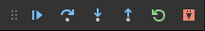
On this toolbar, the disconnect button (⇧F5) stops the debugger and allows the remote program to run to completion. The restart button (⇧⌘F5) restarts the debugger on the local computer but does not restart the remote program. Use the restart button only when you've already restarted the remote program and need to reattach the debugger.

Set configuration options
When you first create launch.json, there are two standard configurations that run the active file in the editor in either the integrated terminal (inside VS Code) or the external terminal (outside of VS Code):
{
"configurations": [
{
"name": "Python Debugger: Current File (Integrated Terminal)",
"type": "debugpy",
"request": "launch",
"program": "${file}",
"console": "integratedTerminal"
},
{
"name": "Python Debugger: Current File (External Terminal)",
"type": "debugpy",
"request": "launch",
"program": "${file}",
"console": "externalTerminal"
}
]
}
Copy
The specific settings are described in the following sections. You can also add other settings, such as args, that aren't included in the standard configurations.
Tip: It's often helpful in a project to create a configuration that runs a specific startup file. For example, if you want to always launch startup.py with the arguments --port 1593 when you start the debugger, create a configuration entry as follows:
{
"name": "Python Debugger: startup.py",
"type": "debugpy",
"request": "launch",
"program": "${workspaceFolder}/startup.py",
"args" : ["--port", "1593"]
},
Copy

name
Provides the name for the debug configuration that appears in the VS Code dropdown list.

type
Identifies the type of debugger to use; leave this set to debugpy for debugging Python code.

request
Specifies the mode in which to start debugging:
- launch: start the debugger on the file specified in program
- attach: attach the debugger to an already running process. See Remote debugging for an example.

program
Provides the fully qualified path to the python program's entry module (startup file). The value ${file}, often used in default configurations, uses the currently active file in the editor. By specifying a specific startup file, you can always be sure of launching your program with the same entry point regardless of which files are open. For example:
"program": "/Users/Me/Projects/MyProject/src/event_handlers/__init__.py",
Copy
You can also rely on a relative path from the workspace root. For example, if the root is /Users/Me/Projects/MyProject then you can use the following example:
"program": "${workspaceFolder}/src/event_handlers/__init__.py",
Copy

module
Provides the ability to specify the name of a module to be debugged, similarly to the -m argument when run at the command line. For more information, see Python.org

python
The full path that points to the Python interpreter to be used for debugging.
If not specified, this setting defaults to the interpreter selected for your workspace, which is equivalent to using the value ${command:python.interpreterPath}. To use a different interpreter, specify its path instead in the python property of a debug configuration.
Alternately, you can use a custom environment variable that's defined on each platform to contain the full path to the Python interpreter to use, so that no other folder paths are needed.
If you need to pass arguments to the Python interpreter, you can use the pythonArgs property.

pythonArgs
Specifies arguments to pass to the Python interpreter using the syntax "pythonArgs": ["<arg 1>", "<arg 2>",...].

args
Specifies arguments to pass to the Python program. Each element of the argument string that's separated by a space should be contained within quotes, for example:
"args": ["--quiet", "--norepeat", "--port", "1593"],
Copy
If you want to provide different arguments per debug run, you can set args to "${command:pickArgs}". This will prompt you to enter arguments each time you start a debug session.
Note: There is a difference in how "${command:pickArgs}" and ["${command:pickArgs}"] are parsed, with specific notice to the usage of []. As an array, all arguments are passed as a single string, without brackets each argument is passed as its own string.

stopOnEntry
When set to true, breaks the debugger at the first line of the program being debugged. If omitted (the default) or set to false, the debugger runs the program to the first breakpoint.

console
Specifies how program output is displayed as long as the defaults for redirectOutput aren't modified.
Value | Where output is displayed
"internalConsole" | VS Code debug console. If redirectOutput is set to False, no output is displayed.
"integratedTerminal" (default) | VS Code Integrated Terminal. If redirectOutput is set to True, output is also displayed in the debug console.
"externalTerminal" | Separate console window. If redirectOutput is set to True, output is also displayed in the debug console.

purpose
There is more than one way to configure the Run button, using the purpose option. Setting the option to debug-test, defines that the configuration should be used when debugging tests in VS Code. However, setting the option to debug-in-terminal, defines that the configuration should only be used when accessing the Run Python File button on the top-right of the editor (regardless of whether the Run Python File or Debug Python File options the button provides is used). Note: The purpose option can't be used to start the debugger through F5 or Run > Start Debugging.

autoReload
Allows for the automatic reload of the debugger when changes are made to code after the debugger execution has hit a breakpoint. To enable this feature set {"enable": true} as shown in the following code.
{
"name": "Python Debugger: Current File",
"type": "debugpy",
"request": "launch",
"program": "${file}",
"console": "integratedTerminal",
"autoReload": {
"enable": true
}
}
Copy
Note: When the debugger performs a reload, code that runs on import might be executed again. To avoid this situation, try to only use imports, constants, and definitions in your module, placing all code into functions. Alternatively, you can also use if __name__=="__main__" checks.

subProcess
Specifies whether to enable subprocess debugging. Defaults to false, set to true to enable. For more information, see multi-target debugging.

cwd
Specifies the current working directory for the debugger, which is the base folder for any relative paths used in code. If omitted, defaults to ${workspaceFolder} (the folder open in VS Code).
As an example, say ${workspaceFolder} contains a py_code folder containing app.py, and a data folder containing salaries.csv. If you start the debugger on py_code/app.py, then the relative paths to the data file vary depending on the value of cwd:
cwd | Relative path to data file
Omitted or ${workspaceFolder} | data/salaries.csv
${workspaceFolder}/py_code | ../data/salaries.csv
${workspaceFolder}/data | salaries.csv

redirectOutput
When set to true (the default for internalConsole), causes the debugger to print all output from the program into the VS Code debug output window. If set to false (the default for integratedTerminal and externalTerminal), program output is not displayed in the debugger output window.
This option is typically disabled when using "console": "integratedTerminal" or "console": "externalTerminal" because there's no need to duplicate the output in the debug console.

justMyCode
When omitted or set to true (the default), restricts debugging to user-written code only. Set to false to also enable debugging of standard library functions.

django
When set to true, activates debugging features specific to the Django web framework.

sudo
When set to true and used with "console": "externalTerminal", allows for debugging apps that require elevation. Using an external console is necessary to capture the password.

pyramid
When set to true, ensures that a Pyramid app is launched with the necessary pserve command.

env
Sets optional environment variables for the debugger process beyond system environment variables, which the debugger always inherits. The values for these variables must be entered as strings.

envFile
Optional path to a file that contains environment variable definitions. See Configuring Python environments - environment variable definitions file.

gevent
If set to true, enables debugging of gevent monkey-patched code.

jinja
When set to true, activates debugging features specific to the Jinja templating framework.

Breakpoints and logpoints
The Python Debugger extension supports breakpoints and logpoints for debugging code. For a short walkthrough of basic debugging and using breakpoints, see Tutorial - Configure and run the debugger.

Conditional breakpoints
Breakpoints can also be set to trigger based on expressions, hit counts, or a combination of both. The Python Debugger extension supports hit counts that are integers, in addition to integers preceded by the ==, >, >=, <, <=, and % operators. For example, you could set a breakpoint to trigger after five occurrences by setting a hit count of >5 For more information, see conditional breakpoints in the main VS Code debugging article.

Invoking a breakpoint in code
In your Python code, you can call debugpy.breakpoint() at any point where you want to pause the debugger during a debugging session.

Breakpoint validation
The Python Debugger extension automatically detects breakpoints that are set on non-executable lines, such as pass statements or the middle of a multiline statement. In such cases, running the debugger moves the breakpoint to the nearest valid line to ensure that code execution stops at that point.

Debugging specific app types
The configuration dropdown provides various different options for general app types:
Configuration | Description
Attach | See Remote debugging in the previous section.
Django | Specifies "program": "${workspaceFolder}/manage.py", "args": ["runserver"]. Also adds "django": true to enable debugging of Django HTML templates.
Flask | See Flask debugging below.
Gevent | Adds "gevent": true to the standard integrated terminal configuration.
Pyramid | Removes program, adds "args": ["${workspaceFolder}/development.ini"], adds "jinja": true for enabling template debugging, and adds "pyramid": true to ensure that the program is launched with the necessary pserve command.
Specific steps are also needed for remote debugging and Google App Engine. For details on debugging tests, see Testing.
To debug an app that requires administrator privileges, use "console": "externalTerminal" and "sudo": "True".

Flask debugging
{
"name": "Python Debugger: Flask",
"type": "debugpy",
"request": "launch",
"module": "flask",
"env": {
"FLASK_APP": "app.py"
},
"args": [
"run",
"--no-debugger"
],
"jinja": true
},
Copy
As you can see, this configuration specifies "env": {"FLASK_APP": "app.py"} and "args": ["run", "--no-debugger"]. The "module": "flask" property is used instead of program. (You may see "FLASK_APP": "${workspaceFolder}/app.py" in the env property, in which case modify the configuration to refer to only the filename. Otherwise, you may see "Cannot import module C" errors where C is a drive letter.)
The "jinja": true setting also enables debugging for Flask's default Jinja templating engine.
If you want to run Flask's development server in development mode, use the following configuration:
{
"name": "Python Debugger: Flask (development mode)",
"type": "debugpy",
"request": "launch",
"module": "flask",
"env": {
"FLASK_APP": "app.py",
"FLASK_ENV": "development"
},
"args": [
"run"
],
"jinja": true
},
Copy

Troubleshooting
There are many reasons why the debugger may not work. Sometimes the debug console reveals specific causes, but the main reasons are as follows:
- Make sure the Python Debugger extension is installed and enabled in VS Code by opening the Extensions view (⇧⌘X) and searching for @installed python debugger.
- The path to the python executable is incorrect: check the path of your selected interpreter by running the Python: Select Interpreter command and looking at the current value:
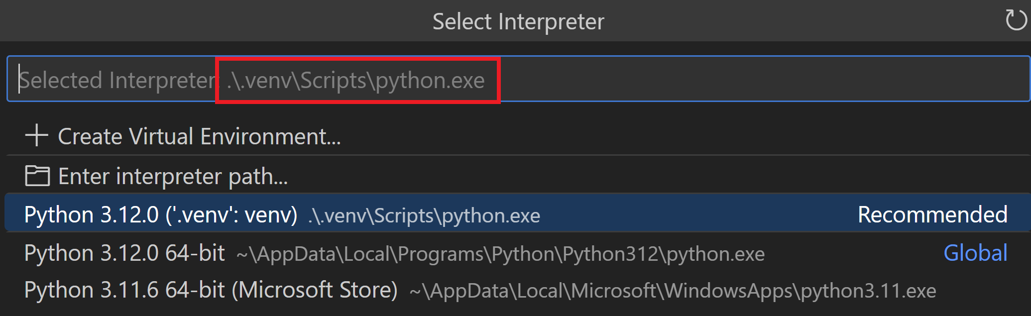
- You have "type" set to the deprecated value "python" in your launch.json file: replace "python" with "debugpy" instead to work with the Python Debugger extension.
- There are invalid expressions in the watch window: clear all expressions from the Watch window and restart the debugger.
- If you're working with a multi-threaded app that uses native thread APIs (such as the Win32 CreateThread function rather than the Python threading APIs), it's presently necessary to include the following source code at the top of whichever file you want to debug:
- import debugpy
- debugpy.debug_this_thread()
Copy
- If you are working with a Linux system, you may receive a "timed out" error message when trying to apply a debugger to any running process. To prevent this, you can temporarily run the following command:
- echo 0 | sudo tee /proc/sys/kernel/yama/ptrace_scope
Copy

Next steps
- Python environments - Control which Python interpreter is used for editing and debugging.
- Testing - Configure test environments and discover, run, and debug tests.
- Settings reference - Explore the full range of Python-related settings in VS Code.
- General debugging - Learn about the debugging features of VS Code.

